IMPROVING RARE LUNG DISEASE DETECTION IN CHEST X-RAYS USING IMBALANCE-AWARE DEEP LEARNING AND EXPLAINABLE AI

BRIAN TING CHIN ING

UNIVERSITI TEKNOLOGI MALAYSIA
PSZ 19:16 (Pind. 1/23)


UNIVERSITI TEKNOLOGI MALAYSIA
DECLARATION OF Choose an item.

Author’s full name | : | BRIAN TING CHIN ING
Student’s Matric No. | : | MEC253007 | Academic Session | : | 1/2526
Date of Birth | : | 07/05/2002 | UTM Email | : | chin-@graduate.utm.my
Choose an item. Title | : | IMPROVING RARE LUNG DISEASE DDETECTION (NODULES AND FIBROSIS) IN CHEST X-RAYS USING DEEP LEARNING WITH CLASS IMBALANCE AND EXPLAINABLE AI
I declare that this Choose an item. is classified as:
☒ | OPEN ACCESS | I agree that my report to be published as a hard copy or made available through online open access.
 | RESTRICTED | Contains restricted information as specified by the organization/institution where research was done.  (The library will block access for up to three (3) years)
☐ | RESTRICTED
☐ | CONFIDENTIAL | Contains confidential information as specified in the Official Secret Act 1972)
(If none of the options are selected, the first option will be chosen by default)

I acknowledged the intellectual property in the Choose an item. belongs to Universiti Teknologi Malaysia, and I agree to allow this to be placed in the library under the following terms :
- This is the property of Universiti Teknologi Malaysia
- The Library of Universiti Teknologi Malaysia has the right to make copies for the purpose of research only.
- The Library of Universiti Teknologi Malaysia is allowed to make copies of this Choose an item. for academic exchange.
Signature of Student:
Signature : 

Full Name: Brian Ting Chin Ing
Date : 25/12/2025
Approved by Supervisor(s)

Signature of Supervisor I: | Signature of Supervisor II
Full Name of Supervisor I  SIM HIEW MOI | Full Name of Supervisor I  PANG YEE YONG
Date: 25 DECEMBER 2025 | Date: 25 DECEMBER 2025

NOTES : If the thesis is CONFIDENTIAL or RESTRICTED, please attach with the letter from the organization with period and reasons for confidentiality or restriction

“We hereby declare that we have read this proposal and in our
opinion this proposal is sufficient in term of scope and quality for the
award of the degree of Master of Philosophy (Computer Science)”

Signature | : | ________________________________
Name of Supervisor I | : | SIM HIEW MOI
Date | : | 25 December 2025
Signature | : | ________________________________
Name of Supervisor II | : | PANG YEE YONG
Date | : | 25 DECEMBER 2025

Declaration of Cooperation

This is to confirm that this research has been conducted through a collaboration Click or tap here to enter text. and Click or tap here to enter text.

Certified by:

Signature | :
Name | :
Position | :
Official Stamp
Date

* This section is to be filled up for theses with industrial collaboration

Pengesahan Peperiksaan

Tesis ini telah diperiksa dan diakui oleh:

Nama dan Alamat Pemeriksa Luar | :
Nama dan Alamat Pemeriksa Dalam | :
Nama Penyelia Lain (jika ada) | :

Disahkan oleh Timbalan Pendaftar di Fakulti:
Tandatangan | :
Nama | :
Tarikh | :

IMPROVING RARE LUNG DISEASE DETECTION IN CHEST X-RAYS USING IMBALANCE-AWARE DEEP LEARNING AND EXPLAINABLE AI

BRIAN TING CHIN ING

A proposal submitted in partial fulfilment of the
requirements for the award of the degree of
Master of Philosophy (Computer Science)

Faculty of Computing
Universiti Teknologi Malaysia

DECEMBER 2025

DECLARATION

I declare that this proposal entitled “IMPROVING RARE LUNG DISEASE DETECTION IN CHEST X-RAYS USING IMBALANCE-AWARE DEEP LEARNING AND EXPLAINABLE AI” is the result of my own research except as cited in the references. The proposal has not been accepted for any degree and is not concurrently submitted in candidature of any other degree.
Signature | : |   ....................................................
Name | : | Brian Ting Chin Ing
Date | : | 25 December 2025

ACKNOWLEDGEMENT
In preparing this thesis, I was in contact with many people, researchers, academicians, and practitioners. They have contributed towards my understanding and thoughts. In particular, I wish to express my sincere appreciation to my main thesis supervisor, Dr. Sim Hiew Moi, for encouragement, guidance, critics and friendship. I am also very thankful to my co-supervisor Dr. Pang Yee Yong for his guidance, advices and motivation. Without their continued support and interest, this thesis would not have been the same as presented here.
I am also indebted to Universiti Teknologi Malaysia (UTM) for funding my Ph.D study. Librarians at UTM, Cardiff University of Wales and the National University of Singapore also deserve special thanks for their assistance in supplying the relevant literatures.
My fellow postgraduate student should also be recognised for their support. My sincere appreciation also extends to all my colleagues and others who have provided assistance at various occasions. Their views and tips are useful indeed. Unfortunately, it is not possible to list all of them in this limited space. I am grateful to all my family member.

ABSTRACT
The application of Deep Learning (DL) in medical imaging has achieved remarkable success; however, standard Convolutional Neural Networks (CNNs) struggle to detect rare thoracic pathologies within large-scale datasets. This study addresses the specific computational challenges associated with detecting Pulmonary Nodules and Pulmonary Fibrosis in the NIH ChestX-ray14 dataset. These diseases exhibit a "long-tail" distribution, resulting in extreme class imbalance (prevalence < 1.5%) where rare features are frequently lost during standard image down sampling. Furthermore, widely used "black-box", which is the unpredictable models, are susceptible to Shortcut Learning, where predictions are based on confounding background artifacts (e.g., hospital tags) rather than anatomical pathology. This research proposes a unified, imbalance-aware deep learning framework to mitigate these limitations. The methodology integrates a DenseNet-121 backbone with a specialized Region of Interest (ROI) Extraction pipeline to physically remove non-medical artifacts and utilizes high-resolution inputs (320 x 320 pixels) to preserve the spatial fidelity of small nodules. To counter gradient suppression caused by the dominance of healthy samples, the model is optimized using Asymmetric Loss (ASL), which decouples positive and negative gradients to prioritize rare-class learning. Preliminary experimental results demonstrate that while baseline models trained with standard Cross-Entropy Loss suffer from artifact reliance and low sensitivity (F1-score < 0.20), the proposed framework significantly improves feature robustness. The integration of Explainable AI (Grad-CAM) further acts as a validation gate, ensuring that model predictions are grounded in relevant lung tissue features. This study will contribute a reliable, clinically relevant computational approach for diagnosing rare diseases in imbalanced medical datasets.

ABSTRAK
Aplikasi Pembelajaran Mendalam (Deep Learning) dalam pengimejan perubatan telah mencapai kejayaan yang memberangsangkan; walau bagaimanapun, Rangkaian Neural Konvolusi (CNN) standard sering gagal mengesan patologi toraks yang jarang berlaku dalam set data berskala besar. Kajian ini menangani cabaran komputasi khusus dalam mengesan Nodul Pulmonari dan Fibrosis Pulmonari menggunakan set data NIH ChestX-ray14. Penyakit-penyakit ini mempamerkan taburan "ekor panjang" (long-tail), yang mengakibatkan ketidakseimbangan kelas yang ekstrem (prevalens < 1.5%) di mana ciri visual halus sering hilang semasa proses pengecilan imej standard. Tambahan pula, model "kotak hitam" (yang sukar ditafsir) sering terdedah kepada Pembelajaran Jalan Pintas (Shortcut Learning), di mana ramalan dibuat berdasarkan artifak latar belakang yang mengelirukan (seperti tag hospital) dan bukannya patologi anatomi. Kajian ini mencadangkan satu kerangka pembelajaran mendalam yang peka terhadap ketidakseimbangan untuk mengatasi batasan ini. Metodologi ini mengintegrasikan tulang belakang DenseNet-121 dengan saluran paip Pengekstrakan Kawasan Berkepentingan (ROI) untuk membuang artifak bukan perubatan secara fizikal, serta menggunakan input beresolusi tinggi (320 x 320 piksel) untuk memelihara ketepatan ruang bagi nodul kecil. Bagi mengatasi penindasan kecerunan yang disebabkan oleh dominasi sampel sihat, model ini dioptimumkan menggunakan Asymmetric Loss (ASL), yang memisahkan kecerunan positif dan negatif untuk mengutamakan pembelajaran kelas yang jarang berlaku. Keputusan eksperimen awal menunjukkan bahawa walaupun model asas yang dilatih dengan Cross-Entropy Loss mengalami masalah kebergantungan artifak dan sensitiviti rendah (skor F1 < 0.20), kerangka yang dicadangkan berjaya meningkatkan keteguhan ciri secara signifikan. Integrasi Kecerdasan Buatan Boleh Terang (Grad-CAM) turut bertindak sebagai gerbang pengesahan, memastikan ramalan model adalah berasaskan ciri tisu paru-paru yang relevan. Kajian ini akan menyumbang satu pendekatan komputasi yang boleh dipercayai dan relevan secara klinikal untuk mendiagnosis penyakit jarang jumpa dalam set data perubatan yang tidak seimbang.

TABLE OF CONTENTS
 | TITLE | PAGE

DECLARATION iii
ACKNOWLEDGEMENT v
ABSTRACT vi
ABSTRAK vii
TABLE OF CONTENTS viii
LIST OF TABLES xii
LIST OF FIGURES xiii
LIST OF ABBREVIATIONS xiv
LIST OF SYMBOLS xv
LIST OF APPENDICES xvi
CHAPTER 1 INTRODUCTION 1
1.1 Introduction 1
1.2 Problem Background 3
1.2.1 The "Long-Tail" Distribution and Gradient Domination 3
1.2.2 The Resolution Bottleneck in Fine-Grained Feature Extraction 3
1.2.3 The Phenomenon of Shortcut Learning and Artifact Reliance 4
1.3 Problem Statement 5
1.3.1 Research Questions 6
1.4 Research Aim 6
1.5 Research Objectives 7
1.6 Scope 7
1.7 Expected Contribution 8
1.7.1 Contribution to the Body of Knowledge on Imbalanced Learning Strategies 9
1.7.2 Contribution to the Research Community on Resource-Efficient Deep Learning 9
1.7.3 Methodological Contribution to Model Robustness and Verification 9
1.8 Organizations of the Thesis 10
CHAPTER 2 LITERATURE REVIEW 12
2.1 Introduction 12
2.2 Overview of Chest Radiography and Standard Benchmarks 13
2.2.1 Data Characteristics and Input Challenges 14
2.3 Rare Lung Disease Detection (Pulmonary Nodules and Fibrosis) 16
2.3.1 The Class Imbalance Problem in Medical Datasets 16
2.3.2 The Phenomenon of Shortcut Learning and Bias 17
2.3.3 Evolution of Deep Learning in Thoracic imaging 17
2.4 Deep Learning Architectures for Thoracic Disease Detection 20
2.4.1 Convolutional Neural Networks (CNNs) and DenseNet 20
2.4.2 Vision Transformers (ViT) and Swin Transformers 21
2.5 Approaches to Mitigate Class Imbalance 22
2.5.1 Data-Level Solutions (Augmentation) 22
2.5.2 Algorithmic-Level Solutions (Loss Functions) 23
2.6 Limitation of existing approach 24
2.7 Advanced Optimization and Reliability Strategies 25
2.7.1 Asymmetric Loss (ASL) for handling Extreme Imbalance 26
2.7.2 Explainable AI (XAI) as Validation mechanism 26
2.7.3 Region of Interest extraction to Prevent Shortcuts 27
2.8 Research Gap and Synthesis 28
CHAPTER 3 RESEARCH METHODOLOGY 31
3.1 Introduction 31
3.2 Proposed Operational Framework and Detail Design 32
3.2.1 Detailed Design of Proposed Solution 34
3.2.2 Problem Formulation and Mapping 38
3.3 Research Framework 39
3.4 Detailed Description of Framework 41
3.4.1 Phase 1: Dataset Preparation 41
3.4.2 Phase 2: Preprocessing and ROI Extraction 41
3.4.3 Phase 3: Model Development and Imbalance Handling 43
3.4.4 Phase 4: Training and Validation 45
3.4.5 Phase 5: Explainability Analysis 45
3.4.6 Phase 6: Testing, Evaluation and Reporting 46
3.5 Resources Needed 46
3.5.1 Hardware Requirements 46
3.5.2 Software and Libraries 47
3.6 Benchmarks/Baselines 48
3.6.1 Internal Baselines (Ablation Study) 48
3.6.2 External Literature Benchmarks 49
3.7 Datasets/Data Collection 50
3.7.1 Dataset Characteristics and Limitations 50
3.7.2 Data Splitting Strategy 52
3.8 Performance/Evaluation 52
3.8.1 Quantitative Evaluation Metrics 52
3.8.2 Qualitative Evaluation (Explainability) 53
3.9 Gantt Chart 54
CHAPTER 4 Initial Result 55
4.1 Introduction 55
4.2 Proposed Method 55
4.2.1 Model Architecture DenseNet-121 55
4.2.2 Input Pipeline and Preprocessing 56
4.2.3 Imbalance-Aware Loss Function 57
4.3 Experimental Design 57
4.4 Results 58
4.4.1 Baseline Model Performance 58
4.4.2 Qualitative Results 59
4.5 Discussion 60
4.6 Conclusion and Further Work 61
REFERENCES 62

LIST OF TABLES
TABLE NO. | TITLE | PAGE
Table 2.1 Comparison of Deep Learning Architectures for Chest X-ray Analysis 15
Table 2.2 Comparison of Deep Learning Architectures for Chest X-ray Analysis 19
Table 2.3 Summary of Research Gaps and Proposed Solutions 29
Table 3.1 Problem Formulation and Methodological Solutions 38
Table 3.2 Software Dependencies and Libraries 47
Table 4.1 Baseline Model Performance 59
Table 4.2 Grad-CAM Visualization of Baseline Model Artifact Reliance 59

LIST OF FIGURES
FIGURE NO. | TITLE | PAGE
Figure 2.1 Examples of Chest X-ray inputs. (A) Normal Control. (B) Pulmonary Nodule, characterized by a distinct, small opacity. (C) Pulmonary Fibrosis, characterized by diffuse reticular patterns 14
Figure 2.2 Timeline of Deep Learning Evolution in Chest X-Rays Analysis 18
Figure 2.3 Structure of a 5-layer dense block (Huang et al., 2017). 21
Figure 2.4 The schematic diagram of CheX-DS (Li et al., 2025). 22
Figure 2.5 Taxonomy of image data augmentation for increasing dataset variability (Shorten & Khoshgoftaar, 2019) 23
Figure 2.6 Comparison of Cross Entropy Loss and Focal Loss with varying focusing parameters (γ). (Lin et al., 2018). 24
Figure 2.7 Comparison of the gradient magnitude for negative samples (Ben-Baruch et al., 2021). 25
Figure 2.8 Illustration of the Region of Interest (ROI) extraction process, where the lung area is segmented and cropped (Ahmed et al., 2022). 27
Figure 3.1 Operational Framework 33
Figure 3.2 Research Framework 40
Figure 3.3 Gantt Chart 54

LIST OF ABBREVIATIONS
ANN | - | Artificial Neural Network
AI | - | Artificial Intelligence
DL | - | Deep Learning
CNN | - | Convolutional Neural Network
ROI | - | Region of Interest
ASL | - | Asymmetric Loss
BCE | - | Binary Cross-Entropy
CAM | - | Class Activation Mapping
GRAD-CAM | - | Gradient-weighted Class Activation Mapping
AUROC | - | Area Under Receiver Operating Characteristic
NIH | - | National Institutes of Health

LIST OF SYMBOLS
$$γ$$ | - | Focusing Parameter
$$α$$ | - | Balancing Parameter
$$σ$$ | - | Sigmoid Function
$$θ$$ | - | Model Parameters
$$∂$$ | - | Partial Derivative
 | - | Summation
$$R$$ | - | Real Number Space
$$p_{t}$$ | - | Target Probability
$$\hat{y}$$ | - | Predicted Label
$$A^{k}$$ | - | Feature Map
$$y^{c}$$ | - | Classification Score

LIST OF APPENDICES
APPENDIX | TITLE | PAGE

INTRODUCTION

Introduction
The proliferation of high-dimensional unstructured data in the last decade has necessitated the development of automated feature extraction methodologies capable of processing information at a scale far exceeding human manual capacity. In the domain of computer vision, this paradigm shift has been driven by the advent of Deep Learning (DL), specifically Convolutional Neural Networks (CNNs), which have replaced traditional hand-crafted feature descriptors, such as Scale-Invariant Feature Transform (SIFT) and Histogram of Oriented Gradients (HOG), with end-to-end learnable representations. This transition has been particularly rigorous in the analysis of radiographic imaging data, where the visual patterns of interest are often stochastic, highly variable, and difficult to parameterize using rigid, rule-based algorithms (Raghu et al., 2019).
The release of large-scale public benchmark datasets, most notably the NIH ChestX-ray14 dataset comprising over 112,000 frontal-view images, has catalysed the development of algorithmic classifiers capable of multi-label pattern recognition (Wang et al., 2017). Foundational studies in this domain, such as the development of CheXNet by Rajpurkar et al. (2017), demonstrated that a 121-layer Densely Connected Convolutional Network (DenseNet-121) could achieve feature extraction performance metrics (e.g., F1-score, AUROC) that are statistically comparable to human benchmarks on common, visually distinct categories (Rajpurkar et al., 2017). This established deep CNNs as the standard architectural baseline for high-dimensional image classification tasks (Irvin et al., 2019).
However, a critical algorithmic disparity persists in the detection of rare and fine-grained visual patterns, specifically those associated with Pulmonary Nodules and Pulmonary Fibrosis. These categories represent a "long-tail" distribution problem within the data space, where the scarcity of positive training examples prevents standard stochastic gradient descent (SGD) optimization from converging to robust decision boundaries (Gao et al., 2025). Furthermore, the visual signatures of these patterns, fine reticular textures for fibrosis and minute focal opacities for nodules, are fundamentally different from the gross pixel intensity shifts seen in majority classes like Effusion or Infiltration. Standard deep learning pipelines, which typically rely on aggressive image down sampling (224 x 224 pixels) and symmetric loss functions (Binary Cross-Entropy), systematically fail to preserve the high-frequency spatial details required to resolve these minority features (Kim et al., 2024).
Moreover, the "black-box" nature of non-linear deep neural networks has raised significant concerns regarding the robustness of feature attribution. Recent literature has formally identified the phenomenon of "Shortcut Learning", where in models minimize loss not by learning the intended robust features, but by exploiting spurious correlations in the background noise, such as acquisition artifacts, text markers, or edge padding (Geirhos et al., 2020). This risk is particularly acute in imbalanced datasets, where the optimization landscape encourages the model to find the "path of least resistance," often bypassing the difficult task of learning subtle minority features in favour of detecting high-contrast artifacts (Boland et al., 2025).
This research proposes a high-performance, imbalance-aware deep learning framework designed to address these specific computational bottlenecks. By integrating resolution-preserving optimization strategies, decoupled training paradigms, and asymmetric cost-sensitive learning, this study aims to improve the algorithmic sensitivity for rare visual patterns while ensuring that model predictions are grounded in relevant feature activations rather than spurious shortcuts.

Problem Background
The application of deep learning to the NIH ChestX-ray14 dataset is currently hindered by three systemic technical limitations that disproportionately affect the feature extraction capabilities for minority classes.

The "Long-Tail" Distribution and Gradient Domination
Real-world datasets often exhibit a long-tail class distribution, a phenomenon where a small number of "head" classes dominate the sample space, while a large number of "tail" classes are severely underrepresented. In the NIH ChestX-ray14 dataset, majority classes such as Infiltration and Effusion appear in thousands of images, whereas minority classes like Pulmonary Fibrosis appear in less than 1.5% of the total dataset, creating a positive-to-negative imbalance ratio exceeding 1:65 (Wang et al., 2017).
Standard training protocols typically utilize Empirical Risk Minimization (ERM) with symmetric loss functions, such as Binary Cross-Entropy (BCE). In this regime, the total loss is the sum of errors across all samples. Due to the extreme imbalance, the accumulated gradients from the massive volume of "easy negative" samples (images without the target feature) overwhelm the sparse learning signal from the rare positive samples (Lin et al., 2017). Consequently, the backpropagation process is dominated by the majority class, causing the model weights to converge toward a trivial local minimum where the minority classes are consistently predicted as negative to minimize global error. Recent surveys on imbalanced learning indicate that standard techniques like random oversampling (ROS) are often insufficient for deep learning models, as they can lead to overfitting of the feature extractor on repeated minority samples without learning generalizable features (Gao et al., 2025).

The Resolution Bottleneck in Fine-Grained Feature Extraction
The second critical limitation is the standard practice of image down sampling. To satisfy the memory constraints of Graphics Processing Units (GPUs) and to leverage transfer learning from models pretrained on ImageNet chest X-rays, originally 1024 x 1024 pixels or larger are typically resized to 224 x 224 pixels (Tan & Le, 2019).
While this resolution is adequate for detecting large, global features, it is destructive for fine-grained patterns. A pulmonary nodule, which can be as small as 3mm in diameter, may occupy less than 2 x 2 pixels in a 224 x 224 image matrix. At this resolution, the feature is mathematically indistinguishable from sensor noise or quantization artifacts. Kim et al. (2024) empirically demonstrated that models trained on standard low-resolution inputs exhibit a significant performance drop in localizing small objects compared to those trained on high-resolution inputs (Kim et al., 2024). This "resolution bottleneck" effectively erases the high-frequency spatial information necessary for texture analysis (fibrosis) and object detection (nodules) before the model even begins to learn.

The Phenomenon of Shortcut Learning and Artifact Reliance
The third challenge is the reliability of the features learned by the model. Deep neural networks are efficient optimization machines that seek to minimize loss by any means possible. When trained on complex datasets with systematic biases, models often discover spurious correlations, features that are statistically associated with a label but have no causal relationship to the target class (Geirhos et al., 2020).
Seminal work by Zech et al. (2018) demonstrated that CNNs could classify images by identifying hospital-specific metal tokens or text markers on the image border, rather than the relevant anatomical region (Zech et al., 2018). More recently, Hill et al. (2024) showed that models could accurately predict a patient's "beer consumption" or "insurance type" from X-ray pixels, proving that deep learning models can easily exploit demographic proxies (such as age-related bone density or site-specific imaging protocols) as shortcuts (Hill et al., 2024). In the context of rare classes, where positive samples are scarce, the risk of the model overfitting to a specific artifact (e.g., a specific "L" marker used only in one hospital ward) is significantly heightened. This necessitates the use of rigorous Explainable AI (XAI) verification to ensure the model is attending to the correct spatial features (Selvaraju et al., 2017).

Problem Statement
Despite the availability of advanced architectures, current deep learning models trained on the NIH ChestX-ray14 dataset fail to achieve robust detection performance for Pulmonary Nodules and Pulmonary Fibrosis. This failure is primarily driven by the severe long-tail label distribution of the dataset, where common diseases such as Infiltration and Effusion appear in thousands of images, while rare diseases such as Fibrosis (<1.5%) and Nodule (<5%) have very limited representation. As a result, standard symmetric loss functions (like Binary Cross-Entropy) allow the accumulated gradients from the massive volume of "easy negative" samples to overwhelm the sparse learning signal from the rare positive samples. Even with standard mitigation strategies like Focal Loss, the optimization landscape remains dominated by the majority class, causing models to converge toward a trivial solution where minority classes are consistently predicted as negative. Consequently, standard CNNs fail to learn robust decision boundaries for these rare categories, necessitating more aggressive decoupling strategies like Asymmetric Loss.
Furthermore, unlike common thoracic abnormalities which present as large global features, pulmonary nodules and fibrosis present with weak, fine-grained, and high-frequency visual signatures. Nodules can be as small as 3mm, and fibrosis manifests as subtle reticular textures. Standard deep learning pipelines aggressively down sample input images to 224 x 224 pixels to satisfy GPU memory constraints, which effectively acts as a low-pass filter. At this resolution, a small nodule occupies less than 2 x 2 pixels, rendering it mathematically indistinguishable from sensor noise or rib shadows. This "resolution bottleneck" erases the critical spatial information required for detection before the model even begins to learn, meaning architectures fail to localize these small objects unless higher-resolution inputs (e.g., 320 x 320 pixels) are employed to preserve spatial fidelity.
Finally, deep learning models trained on imbalanced medical data are highly susceptible to "Shortcut Learning," where they minimize loss by exploiting spurious correlations rather than learning true pathology. Recent studies have demonstrated that models often achieve moderate AUC scores by detecting hospital-specific metal tokens, text markers, or demographic proxies instead of the actual disease. For rare diseases with weak feature representations, this risk is magnified; the model is incentivized to find the "path of least resistance" (e.g., an "L" marker associated with a specific scanner) rather than struggling to learn the difficult fibrotic texture. This reliance on non-robust features renders standard performance metrics unreliable and necessitates the use of Region of Interest (ROI) Extraction to remove artifacts, coupled with Explainable AI (XAI) to verify that predictions are grounded in anatomical reality.

Research Questions
- How do resolution down sampling and extreme class imbalance impact the feature extraction capability of standard CNN architectures for rare lung pathologies?
- To what extent does the proposed imbalance-aware framework (integrating ROI extraction and Asymmetric Loss) improve the detection sensitivity for Pulmonary Nodules and Fibrosis compared to baseline models?
- How effective is the proposed hybrid validation pipeline using Grad-CAM in verifying the anatomical reliability of the model predictions and mitigating shortcut learning?

Research Aim
The aim of this research is to develop an enhanced deep learning framework that improves the detection sensitivity and interpretability stability for rare thoracic abnormalities, specifically Pulmonary Nodules and Pulmonary Fibrosis, by integrating imbalance-aware optimization and resolution-preserving training strategies within a DenseNet-121 architecture.

Research Objectives
- To investigate the impact of resolution down sampling and class imbalance on the feature extraction capability of standard CNN architectures for rare lung pathologies.
- To design and develop an imbalance-aware deep learning framework augmented with Region of Interest (ROI) extraction and Asymmetric Loss (ASL) to predict Pulmonary Nodules and Fibrosis.
- To develop and evaluate a hybrid validation pipeline using Explainable AI (Grad-CAM) and quantitative metrics (F1-Score) to verify the anatomical reliability of the proposed model.

Scope
The research objectives are achieved by identifying the problem scope, which covers the following aspects:
- Dataset Utilization and Target Pathologies: The study utilizes the NIH ChestX-ray14 dataset exclusively, focusing solely on frontal-view chest radiographs without the incorporation of external clinical data, private hospital datasets, or multi-modal sources such as CT or MRI scans. The investigation is confined to a multi-label classification setting, with a specific emphasis on detecting two underrepresented and visually subtle abnormalities: Pulmonary Nodule and Pulmonary Fibrosis. The remaining twelve disease classes present in the dataset are utilized only as background or negative samples to support the multi-label learning task.
- Model Architecture and Resolution Constraints: In terms of model development, the research focuses on Convolutional Neural Network (CNN) architectures, specifically selecting DenseNet-121 as the primary model due to its proven feature reuse capabilities. To address the critical issue of feature erasure in small objects, the study implements a high-resolution training pipeline (320 x 320 pixels), utilizing optimization techniques such as gradient accumulation to ensure feasibility within standard computational constraints. The study does not extend to object detection (bounding box regression) or semantic segmentation tasks.
- Algorithmic Imbalance Mitigation: The imbalance mitigation strategy is restricted to algorithmic interventions rather than synthetic data generation. Specifically, the study implements Asymmetric Loss (ASL) and Decoupled Training to address the "long-tail" distribution of the target diseases. Generative methods, such as Generative Adversarial Networks (GANs) for synthetic data augmentation, are excluded from the scope of this research.
- Explainability and Evaluation Framework: The explainability analysis is limited to activation-based visualization methods. The study benchmarks Grad-CAM to evaluate the stability of visual explanations and to verify that predictions are grounded in anatomical reality rather than background artifacts (shortcut learning). The evaluation of model performance relies on quantitative metrics such as F1-Score, Sensitivity (Recall), and AUROC, alongside qualitative assessments of heatmap fidelity. This research is conducted entirely within a computational framework and does not involve clinical validation by human experts.

Expected Contribution
This research contributes to the body of technical knowledge and the research community by validating a unified framework for rare disease detection. The contributions are categorized as follows:

Contribution to the Body of Knowledge on Imbalanced Learning Strategies
This study contributes empirical evidence to the field of computer vision by systematically validating Asymmetric Loss (ASL) as a superior alternative to standard Focal Loss for multi-label medical datasets. While previous studies have addressed general imbalance, this research specifically quantifies the efficacy of gradient decoupling for ultra-rare classes (<1.5% prevalence), providing a reference benchmark for future researchers dealing with extreme "long-tail" distributions in medical imaging.

Contribution to the Research Community on Resource-Efficient Deep Learning
A significant barrier for the academic community is the high computational cost of processing medical images. This research contributes a proven implementation framework for high-resolution training (320 x 320 pixels) on standard consumer hardware. By demonstrating the effective integration of Gradient Accumulation and Mixed Precision, this study offers a replicable pathway for researchers to overcome the "Resolution Bottleneck" without access to industrial-scale computing clusters.

Methodological Contribution to Model Robustness and Verification
This research contributes a rigorous validation protocol for deep learning reliability. By shifting the use of Explainable AI (Grad-CAM) from a passive visualization tool to an active "Anti-Shortcut" debugging mechanism, this study demonstrates a practical methodology for detecting and removing artifact reliance (e.g., hospital tags). This provides a technical workflow that future developers can adopt to ensure their models are learning robust anatomical features rather than spurious correlations.

Organizations of the Thesis
This thesis is structured into five cohesive chapters, designed to guide the reader from the theoretical underpinnings of deep learning in medical imaging to the experimental validation of the proposed high-performance framework.
Chapter 1 establishes the research context, articulating the critical transition from manual feature engineering to deep representation learning in chest radiography. It defines the specific problem scope, focusing on the algorithmic failure modes associated with detecting Pulmonary Nodules and Pulmonary Fibrosis in imbalanced datasets. The chapter outlines the research aim, specific technical objectives, and the boundaries of the study, concluding with the expected contributions to the field of computer vision.
Chapter 2 provides a critical analysis of the existing body of knowledge. It reviews the evolution of architectural standards from CheXNet (DenseNet-121) to modern alternatives like EfficientNet and Vision Transformers, justifying the continued relevance of CNNs for texture-based feature extraction. Furthermore, it extensively critiques current imbalance mitigation strategies (Focal Loss, Oversampling) and examines the theoretical risks of Shortcut Learning and Label Noise, establishing the necessity for the advanced interventions proposed in this study.
Chapter 3 details the technical implementation of the proposed framework. It provides the mathematical formulation of the Asymmetric Loss (ASL) function and the Decoupled Training strategy. It describes the high-resolution data pipeline, including specific preprocessing steps, augmentation policies (Random Resized Crop), and the memory-optimization techniques (Gradient Accumulation) required to train the DenseNet-121 backbone at 320 x 320 resolution. The chapter also defines the setup for Explainable AI analysis using Score-CAM.
Chapter 4 presents the preliminary experimental findings obtained from the baseline models (Standard DenseNet-121 and ResNet-50) trained under standard conditions (224 x 224 resolution, Cross-Entropy Loss). It provides a quantitative analysis of the "Resolution Bottleneck" and "Class Imbalance Bias," empirically demonstrating the low sensitivity and F1-scores for rare classes in the absence of the proposed interventions. Furthermore, it includes a qualitative "Failure Analysis" using Grad-CAM visualizations to reveal instances of Shortcut Learning, where baseline models incorrectly focus on background artifacts, thereby computationally justifying the necessity for the advanced framework proposed in Chapter 3.

LITERATURE REVIEW

Introduction
This chapter provides a comprehensive review of the current state of the art in thoracic disease detection. It begins by establishing the significance of detecting rare lung pathologies and the mathematical context of class imbalance and shortcut learning (Section 2.2). Subsequently, it critically analyses existing solutions, including standard architectures like DenseNet-121 and loss functions designed for imbalance (Section 2.3). Finally, the chapter identifies specific research gaps, highlighting the limitations of current approaches in simultaneously addressing data imbalance and model explainability, thus motivating the proposed framework.
The rapid advancement of Deep Learning (DL) has fundamentally transformed the landscape of medical image analysis, particularly in the domain of automated thoracic disease detection (Lei et al., 2025). While early Computer-Aided Detection (CAD) systems relied heavily on manual feature extraction and handcrafted rules (Wang et al., 2017), modern Convolutional Neural Networks (CNNs) and Vision Transformers have demonstrated the ability to learn complex hierarchical representations directly from raw pixel data (Rana et al., 2025; Huang et al., 2017). Despite these technological strides, the deployment of such models in real-world clinical scenarios faces significant hurdles. The primary challenges identified in recent literature are twofold: the severe class imbalance inherent in medical datasets, where rare pathologies are vastly underrepresented (Gao et al., 2025), and the phenomenon of "shortcut learning," where models rely on confounding background signals rather than genuine pathological features (Geirhos et al., 2020; Hill et al., 2024).

Overview of Chest Radiography and Standard Benchmarks
Chest radiography (CXR) represents the most widely used diagnostic imaging modality in global healthcare due to its cost-effectiveness, low radiation dose, and high accessibility. Clinically, it serves as the primary screening tool for a broad spectrum of thoracic pathologies, ranging from acute infections like pneumonia to chronic conditions such as pulmonary fibrosis and lung nodules. However, the manual interpretation of chest X-rays is complex and subject to significant inter-observer variability. The projection of complex 3D anatomical structures (ribs, clavicles, heart, and vessels) onto a 2D plane creates visual overlaps that frequently obscure subtle pathologies. Ramli et al. (2025) note that small pulmonary nodules are frequently "hidden" behind rib shadows or the cardiac silhouette, leading to high false-negative rates in manual diagnosis.
To automate this diagnostic process, the research community relies on standardized large-scale benchmarks. The NIH ChestX-ray14 dataset, released by Wang et al. (2017), is the foundational dataset for this domain and the primary source for this study. Comprising 112,120 frontal-view X-ray images from 30,805 unique patients, it was the first dataset to provide the volume of data necessary to train deep Convolutional Neural Networks (CNNs). While it enabled the breakthrough of deep learning in medical imaging, the dataset introduces three proven limitations that constrain standard model performance:
- Weak Supervision: The labels were generated via Natural Language Processing (NLP) from text reports rather than pixel-level annotations. Kim et al. (2024) demonstrated that this lack of spatial guidance hampers the detection of fine-grained objects like nodules.
- Severe Class Imbalance: The dataset exhibits a "Long-Tail" distribution, where rare classes like Fibrosis (<1.5%) are overwhelmed by common classes, causing standard loss functions to fail.
- Artifact Bias: Zech et al. (2018) proved that models trained on this multi-centre data often engage in "Shortcut Learning," relying on hospital-specific tags rather than pathology.

Data Characteristics and Input Challenges
The NIH ChestX-ray14 dataset presents unique challenges distinct from natural image datasets.
- Subtlety of features: Unlike distinct objects in natural images, diseases like Fibrosis present as diffuse interstitial thickening with no clear edges. Nodules are often tiny and can be easily obscured by ribs or the heart shadow, making detection computationally difficult.
- Label Noise: The labels in large datasets are often "weak," extracted from text reports via NLP rather than biopsy-confirmed pixel annotations. This introduces label noise that hampers training efficiency.
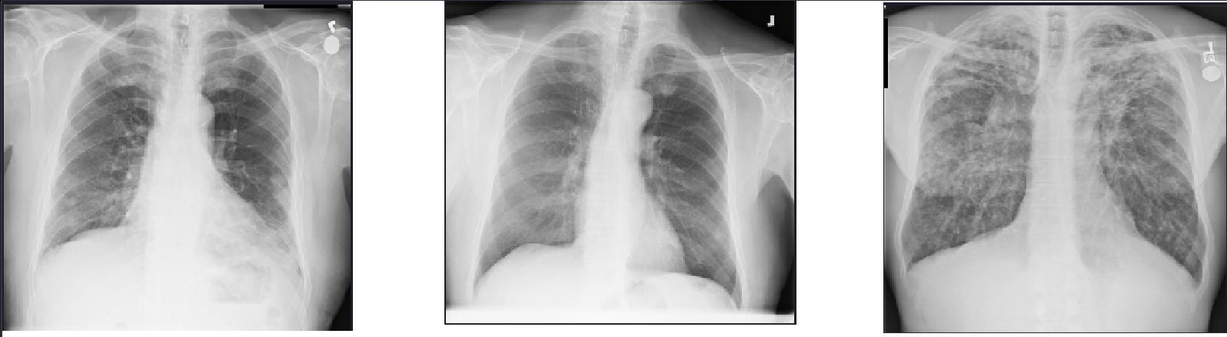
Figure 2.1 Examples of Chest X-ray inputs. (A) Normal Control. (B) Pulmonary Nodule, characterized by a distinct, small opacity. (C) Pulmonary Fibrosis, characterized by diffuse reticular patterns

Table 2.1 Comparison of Deep Learning Architectures for Chest X-ray Analysis
Loss Function | Primary Focus | Mechanism | Limitation in Chest X-ray | Source
Cross-Entropy (CE) | Global Accuracy | Penalizes all errors equally. | Dominated by "easy negatives" (background); ignores rare classes. | Wang et al. (2017)
Weighted CE (WCE) | Minority Class | Adds static weight to positive class. | Increases false positives; hard to tune for multi-label. | Wang et al. (2017)
Focal Loss (FL) | Hard Samples | Down-weights easy samples using γ. | Gradient Suppression: Negatives still contribute noise, overwhelming rare signals. | Lin et al. (2017)
Asymmetric Loss (ASL) | Extreme Imbalance | Decouples positive/negative gradients. | Hard thresholding removes easy negatives entirely; preserves rare gradients. | Ben-Baruch et al. (2021)

Rare Lung Disease Detection (Pulmonary Nodules and Fibrosis)
Thoracic diseases encompass a wide range of pathologies, yet they differ significantly in their visual manifestation and prevalence. While common conditions like Effusion or Infiltration may present as large, distinct opacities, rare diseases such as Pulmonary Nodules and Pulmonary Fibrosis are characterized by subtle, localized, or texture-based features that are easily overlooked by standard algorithms (Nishikiori et al., 2021).
Recent systematic reviews indicate that the accurate detection of lung nodules is a critical component of early lung cancer screening, yet it remains a computationally difficult task due to the high variability in nodule size, density, and surrounding anatomical noise (Ramli et al., 2025). Similarly, fibrosis presents as a diffuse interstitial pattern that requires the model to learn fine-grained textural dependencies rather than simple object detection (Nishikiori et al., 2021). The "significance" here is technical as well as practical: these classes represent the "hard examples" in deep learning, data points that yield high loss values and are frequently misclassified by models optimized for global accuracy (Kim et al., 2024). Furthermore, the accuracy of detection is heavily dependent on the quality of labels, where pixel-level annotations have been shown to outperform weak image-level labels (Kim et al., 2024).

The Class Imbalance Problem in Medical Datasets
A persuasive issue in medical computer vision is the "Long-Tail" distribution of data. In the context of the NIH ChestX-ray14 dataset, which serves as a standard benchmark for this domain, the distribution of disease labels is highly skewed (Wang et al., 2017). Common conditions may have tens of thousands of examples, while rare categories contain significantly fewer.
Gao et al. (2025) define class imbalance as a scenario where the class distribution is not uniform, leading standard training objectives (such as Cross-Entropy Loss) to be dominated by the majority class. In this environment, a model can achieve a high overall accuracy by simply predicting the absence of the rare disease for every image, resulting in a model that is statistically "accurate" but functionally useless for detecting rare pathologies like fibrosis (Ben-Baruch et al., 2021; Gao et al., 2025). This necessitates the exploration of specialized loss functions and sampling strategies to prevent the majority class from overwhelming the learning process (Lin et al., 2017).

The Phenomenon of Shortcut Learning and Bias
Most insidious problem in modern medical AI is "Shortcut Learning," a term formalized by Geirhos et al. (2020) to describe decision rules that perform well on standard benchmarks but fail to generalize because they rely on spurious correlations rather than causal factors (Geirhos et al., 2020).
In the specific context of Chest X-rays, Hill et al. (2024) demonstrated that deep learning models frequently learn to identify "confounding variables" such as hospital-specific tokens, radiographic markers, or image artifacts rather than the pathology itself (Hill et al., 2024). Furthermore, Chen et al. (2025) revealed that algorithms trained on "normal" chest X-rays could accurately predict non-medical attributes such as health insurance type, indicating that models are extracting socioeconomic bias encoded in the image acquisition process (Chen et al., 2025). These findings underscore the critical need for Explainable AI (XAI) techniques, such as Grad-CAM, not just for interpretation, but as a validation mechanism to ensure the model is focusing on the lung field and not on background shortcuts (Selvaraju et al., 2018; Boland et al., 2025; Ahmed et al., 2022).

Evolution of Deep Learning in Thoracic imaging
To contextualize the proposed methodology, it is necessary to trace the evolution of deep learning architectures in this field. The progression has moved from standard Convolutional Neural Networks (CNNs) to more complex architectures capable of handling global context.

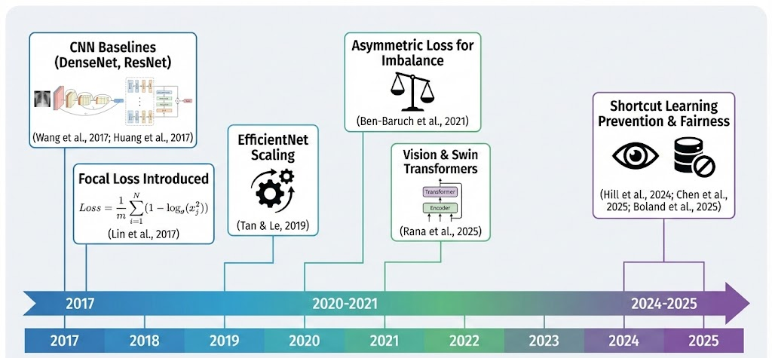
Figure 2.2 Timeline of Deep Learning Evolution in Chest X-Rays Analysis

Figure 2.2 illustrates the chronological evolution of deep learning methodologies in chest X-ray analysis, synthesized from the reviewed literature. The initial phase (2017–2019) focused on establishing architectural baselines, where Wang et al. (2017) and Huang et al. (2017) demonstrated the efficacy of CNNs like ResNet and DenseNet-121 for multi-label classification. As the field matured (2020–2022), the research focus shifted toward specialized optimization to address data limitations. This era saw the introduction of Focal Loss by Lin et al. (2017) to handle hard samples and EfficientNet by Tan & Le (2019) to optimize scaling efficiency. Furthermore, to tackle extreme class imbalance, Ben-Baruch et al. (2021) proposed Asymmetric Loss (ASL), while recent works by Rana et al. (2025) have begun exploring Vision Transformers (ViT) to capture long-range global dependencies that standard CNNs miss.
Most recently (2024–2025), the paradigm has expanded beyond raw accuracy to emphasize clinical reliability and fairness. Recent studies by Hill et al. (2024) and Boland et al. (2025) highlight the critical need to mitigate "Shortcut Learning," where models exploit hospital-specific artifacts rather than learning true pathology. Additionally, Chen et al. (2025) revealed that algorithms can inadvertently learn demographic biases from source data, such as predicting insurance type from X-rays. Consequently, modern frameworks must now integrate validation mechanisms, such as Explainable AI, to ensure that high performance metrics reflect genuine anatomical understanding rather than spurious correlations.
Table 2.2 Comparison of Deep Learning Architectures for Chest X-ray Analysis
Architecture | Key Mechanism | Pros | Cons | Reference
ResNet-50 | Residual Connections (Skip connections) | Solves the vanishing gradient problem; allows training of very deep networks. | Requires more parameters than DenseNet to achieve similar accuracy; lower feature reuse. | He et al. (2016)
DenseNet-121 | Dense Connections (Feature Reuse) | High parameter efficiency; maximizes information flow; strong gradient propagation. | High memory access cost during training due to concatenation operations. | Huang et al. (2017)
Swin Transformer | Shifted Windows (Self-Attention) | Captures long-range global dependencies better than CNNs; state-of-the-art accuracy. | Computationally expensive; requires massive datasets to converge (data-hungry). | Liu et al. (2021)
CheX-DS (Ensemble) | Hybrid (CNN + Transformer) | Combines local feature extraction (DenseNet) with global context (Swin). | High computational complexity; difficult to deploy in resource-constrained clinical settings. | Li et al. (2025)

Deep Learning Architectures for Thoracic Disease Detection
The efficacy of any automated diagnosis system is fundamentally limited by the architecture's ability to extract semantic features from high-resolution medical images.

Convolutional Neural Networks (CNNs) and DenseNet
Convolutional Neural Networks (CNNs) have served as the backbone of medical image analysis. Among various CNN architectures, the Densely Connected Convolutional Network (DenseNet), specifically DenseNet-121, has established itself as the baseline for thoracic disease classification. Unlike traditional networks like ResNet, which sum features via residual connections, DenseNet connects each layer to every other layer in a feed-forward fashion. The input to the ƪ-th layer, $x_{l}$, is defined as the concatenation of feature maps from all preceding layers.
This "feature reuse" mechanism is particularly advantageous for medical imaging because it mitigates the vanishing gradient problem, allowing the training of deeper networks with fewer parameters. In the seminal work "CheXNet," Rajpurkar et al. (2017) utilized a 121-layer DenseNet to achieve radiologist-level performance on pneumonia detection in the ChestX-ray14 dataset. However, CNNs possess an inherent limitation: the "locality bias," where convolution operations only process a small window of pixels at a time. While this is excellent for detecting local textures, it struggles to capture long-range dependencies, such as comparing the symmetry between the left and right lung fields, which is often crucial for diagnosing diffuse diseases like fibrosis.
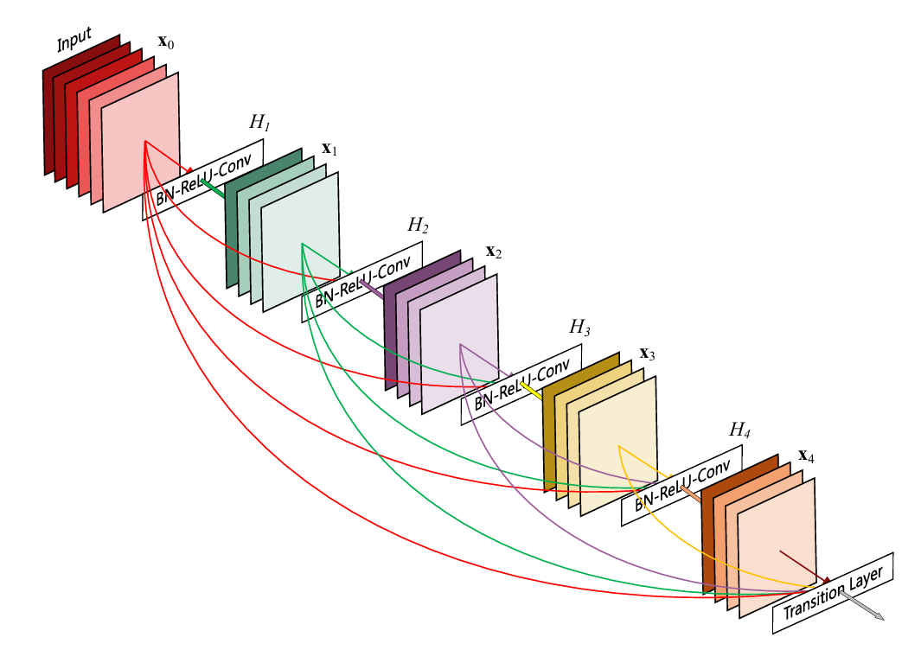
Figure 2.3 Structure of a 5-layer dense block (Huang et al., 2017).

Vision Transformers (ViT) and Swin Transformers
To address the limitations of CNNs, the field has recently pivoted toward Transformer-based architectures. The Swin Transformer (Hierarchical Vision Transformer using Shifted Windows) represents the current state-of-the-art in this domain. Unlike CNNs, Transformers utilize "Self-Attention" mechanisms to calculate the relationship between every pixel patch and every other patch in the image, effectively capturing global context from the very first layer.
Rana et al. (2025) demonstrated that Swin Transformers significantly outperform standard CNNs in detecting complex thoracic diseases because they can model these global anatomical relationships. Furthermore, recent "Ensemble" approaches, such as CheX-DS proposed by Li et al. (2025), combine the strengths of both worlds: using DenseNet to extract fine-grained local features and a Swin Transformer to capture global context. This hybrid approach has shown superior performance in distinguishing between visually similar pathologies compared to single-model baselines.
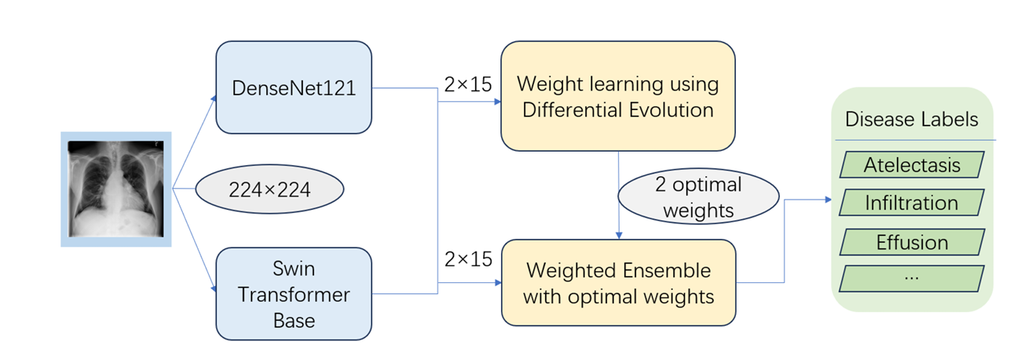
Figure 2.4 The schematic diagram of CheX-DS (Li et al., 2025).

Approaches to Mitigate Class Imbalance
Medical datasets typically exhibit a "Long-Tail" distribution, where common diseases (e.g., Infiltration) are abundant, while critical conditions (e.g., Nodules, Fibrosis) are rare. Standard training methods fail in this environment because the model optimizes for the majority class to minimize overall error.

Data-Level Solutions (Augmentation)
Data augmentation attempts to balance the dataset by artificially creating new samples of the minority class (Shorten & Khoshgoftaar, 2019). Geometric transformations such as rotation, horizontal flipping, and cropping are standard practices to reduce overfitting and improve invariance (Shorten & Khoshgoftaar, 2019). Additionally, "Weakly Labeled Data Augmentation" (WLDA) has been proposed to utilize noisy labels to increase the training pool, a method successfully applied during the COVID-19 pandemic to handle data scarcity (Rajaraman & Antani, 2020). However, standard augmentation fails to bridge the "semantic gap" for rare diseases, as simple geometric transformations cannot generate the complex, disease-specific textural features required to recognize pathologies like fibrosis (Nishikiori et al., 2023).
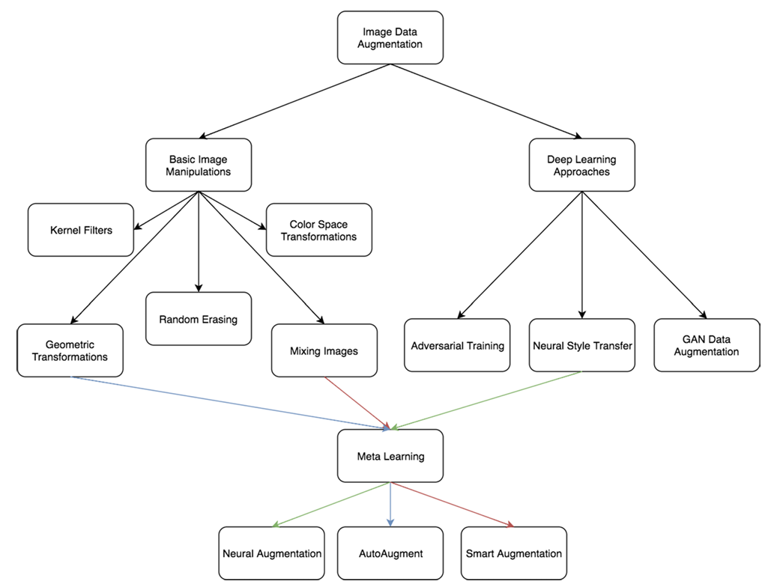
Figure 2.5 Taxonomy of image data augmentation for increasing dataset variability (Shorten & Khoshgoftaar, 2019)

Algorithmic-Level Solutions (Loss Functions)
Algorithmic solutions modify the objective function to penalize the model more heavily for misclassifying rare cases.
- Weighted Cross-Entropy (WCE): This approach assigns a static weight to the positive class, forcing the model to prioritize minority samples.
- Focal Loss (FL): Introduced by Lin et al. (2017), Focal Loss is designed to address the problem of "easy negatives". In a chest X-ray, most of the image is background (easy to classify), which allows these easy examples to sum up and dominate the gradient. Focal Loss adds a modulating factor to down-weight these easy examples, focusing training on hard positives.
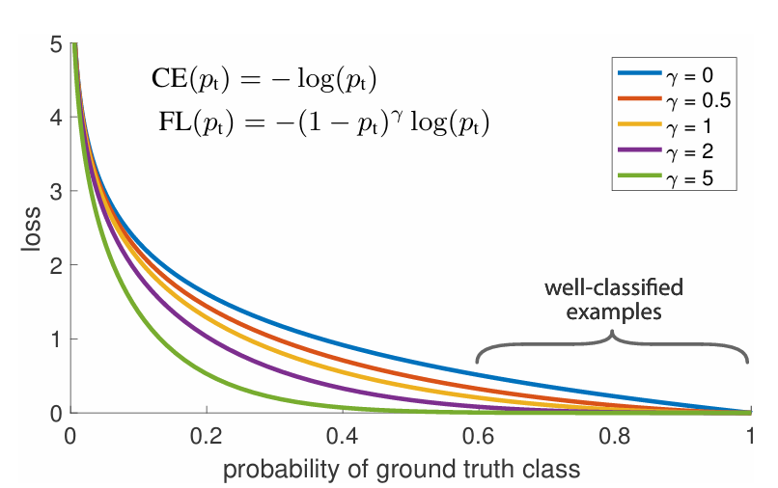
Figure 2.6 Comparison of Cross Entropy Loss and Focal Loss with varying focusing parameters (γ). (Lin et al., 2018).

Limitation of existing approach
Despite these advancements, significant limitations persist, particularly in the context of multi-label classification for rare diseases.
- Inefficiency of Focal Loss in Multi-Label Settings: While Focal Loss works well for single objects, Ben-Baruch et al. (2021) identified a critical flaw when applied to multi-label datasets like ChestX-ray14. In these datasets, a single image acts as a positive sample for one disease but a negative sample for many others. Focal Loss treats all negatives equally, leading to "gradient suppression," where the gradients from the rare positive class are overwhelmed by the dampened gradients of the numerous negative classes.
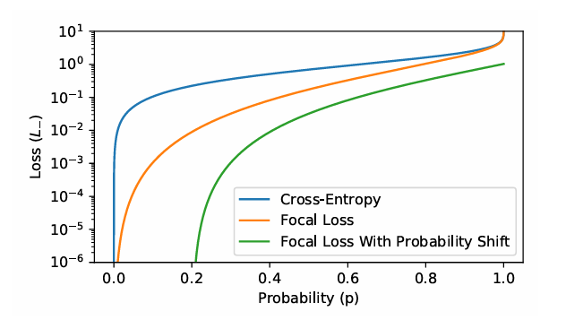
Figure 2.7 Comparison of the gradient magnitude for negative samples (Ben-Baruch et al., 2021).
- Shortcut Learning and Lack of Interpretability: High accuracy on a test set does not imply clinical reliability. Geirhos et al. (2020) demonstrated that models frequently engage in "Shortcut Learning," relying on confounding variables such as hospital-specific text markers or image artifacts instead of actual pathology. Furthermore, Chen et al. (2025) found that algorithms could predict non-medical attributes like insurance type from X-rays, indicating significant hidden bias. Current architectures do not inherently prevent this; they require external validation via Explainable AI (XAI) tools like Grad-CAM to verify the decision capability.

Advanced Optimization and Reliability Strategies
While standard architectures and loss functions provide a foundation for thoracic disease detection, they remain insufficient for addressing the specific challenges of rare pathologies (nodules, fibrosis) and shortcut learning. This section explores advanced alternatives, specifically Asymmetric Loss and Explainable AI (XAI) and synthesizes the research gap that this thesis aims to address.

Asymmetric Loss (ASL) for handling Extreme Imbalance
To overcome the limitations of Focal Loss in multi-label settings, Ben-Baruch et al. (2021) proposed Asymmetric Loss (ASL). Unlike Focal Loss, which applies the same focusing mechanism to both positive and negative samples, ASL decouples the gradient contribution of the two classes (Ben-Baruch et al., 2021).
In a dataset like NIH ChestX-ray14, where negative samples (healthy tissue) vastly outnumber positive samples (nodules), ASL applies "hard thresholding" to the negative gradients. This allows the model to aggressively suppress the loss from easy negative samples while maintaining strong gradients for the rare positive samples (Ben-Baruch et al., 2021). By shifting the probability margin for negative samples ($m$), ASL prevents the "gradient suppression" phenomenon observed with Focal Loss, ensuring that the model continues to learn from rare fibrosis cases even when the background is easily classified as "normal" (Ben-Baruch et al., 2021).

Explainable AI (XAI) as Validation mechanism
The danger of shortcut learning necessitates moving beyond "black-box" predictions. Gradient-weighted Class Activation Mapping (Grad-CAM), introduced by Selvaraju et al. (2018), has emerged as a standard technique for visualizing model decisions (Selvaraju et al., 2018). Grad-CAM uses the gradients of the target concept (e.g., "Pneumonia") flowing into the final convolutional layer to produce a coarse localization map highlighting the important regions in the image (Selvaraju et al., 2018).
However, in current literature, Grad-CAM is primarily used for post-hoc interpretation, simply showing the doctor where the model looked after the diagnosis is made (Ahmed et al., 2022). A significant potential alternative is to use XAI during the development phase to identify and remove biases. For example, if Grad-CAM reveals that the model is focusing on a hospital tag in the corner rather than the lung field, that model should be rejected regardless of its high accuracy score (Boland et al., 2025). This shifts XAI from a visualization tool to a critical quality assurance mechanism for preventing shortcut learning (Hill et al., 2024).

Region of Interest extraction to Prevent Shortcuts
A direct data-level alternative to prevent shortcut learning is Region of Interest (ROI) Extraction. Ahmed et al. (2022) utilized a preprocessing pipeline where the lung region is explicitly detected and cropped from the raw X-ray before classification. This process removes the peripheral areas of the image such as the shoulders, abdomen, and image borders, which frequently contain confounding artifacts like hospital tags, cables, and text annotations (Ahmed et al., 2022). By physically removing these non-medical features, the model is forced to learn features solely from the lung tissue, effectively neutralizing the "shortcut" bias described by Geirhos et al. (2020).
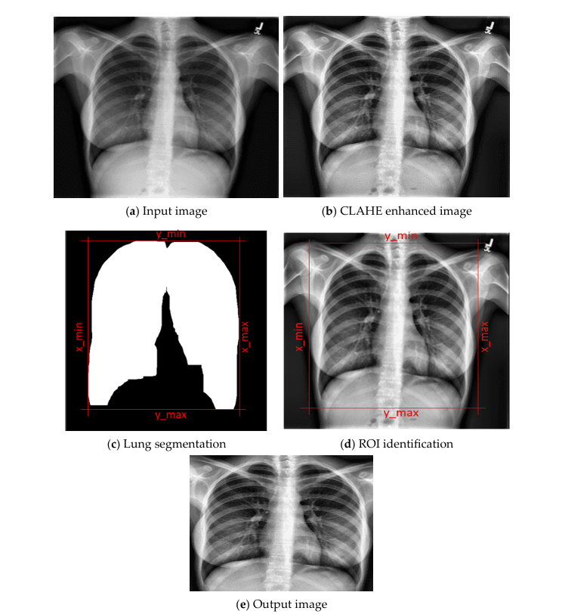
Figure 2.8 Illustration of the Region of Interest (ROI) extraction process, where the lung area is segmented and cropped (Ahmed et al., 2022).

Research Gap and Synthesis
While recent advancements in deep learning have improved general thoracic disease detection, a critical review of the literature reveals three fundamental gaps that prevent current state-of-the-art models from reliably detecting rare pathologies like Pulmonary Nodules and Fibrosis. These limitations directly motivate the specific interventions proposed in this study.
- The "Resolution-Texture" Mismatch in Architecture Design:
Current benchmarks, such as those by Li et al. (2025) and Rana et al. (2025), focus heavily on architectural complexity, proposing elaborate ensembles of Vision Transformers (Swin-ViT) and CNNs. However, these studies overwhelmingly rely on standard input resolutions (224 x 224 pixels) to conserve computational resources. Kim et al. (2024) empirically demonstrated that this aggressive down sampling acts as a low-pass filter, effectively erasing the high-frequency spatial details required to resolve 3mm nodules and subtle fibrotic reticulations. There is a clear gap in the literature regarding resource-efficient high-resolution feature extraction: existing models are either too shallow to capture semantic context or too computationally heavy to process the 320+ pixel inputs necessary for rare disease visibility.
- Failure of Standard Imbalance Strategies in Multi-Label Settings:
Although Class Imbalance is a well-known problem, the standard solution, Focal Loss is mathematically insufficient for the extreme "Long-Tail" distribution of the NIH ChestX-ray14 dataset. As noted by Ben-Baruch et al. (2021), Focal Loss was designed for single-object detection and suffers from "gradient suppression" in multi-label environments. In a dataset where Fibrosis appears in less than 1.5% of images, the accumulated gradients from the 98.5% "easy negative" background overwhelm the sparse positive signal, even with focal weighting. There is a lack of research validating decoupled gradient optimization (Asymmetric Loss) specifically for thoracic imaging, leaving a gap in how to train models for ultra-rare classes without succumbing to the majority background bias).
- XAI as Passive Visualization rather than Active Validation:
Finally, while Explainable AI (Grad-CAM) is frequently cited in medical imaging studies (Ahmed et al., 2022), it is predominantly used as a passive, post-hoc visualization tool to "interpret" successful predictions. It is rarely integrated into the development pipeline as a rigorous quality assurance mechanism. Given the recent findings by Hill et al. (2024) and Chen et al. (2025) regarding "Shortcut Learning" where models predict based on hospital tags or demographic proxies, there is a critical need to operationalize XAI. The current literature lacks a framework that treats XAI spatial consistency as a mandatory validation gate, accepting models only if their focus aligns with anatomical reality rather than spurious correlations.
Proposed Solution: This research proposes to bridge these specific gaps by developing a unified Imbalance-Aware Deep Learning Framework. Unlike previous studies that treat these problems in isolation, this study integrates DenseNet-121 (for feature reuse) with Asymmetric Loss (to solve the multi-label suppression) and utilizes ROI Extraction & Grad-CAM (to physically remove and logically detect shortcuts). This holistic approach aims to demonstrate that accurate rare disease detection requires not just deeper networks, but a fundamental shift in how data resolution, loss functions, and model validity are handled.

Table 2.3 Summary of Research Gaps and Proposed Solutions
Domain | Existing Problem | Identified Limitation (Research Gap) | Proposed Solution
Architecture | Deep networks suffer from vanishing gradients and low feature reuse. | ResNet captures features but is less efficient than DenseNet; Transformers are too heavy. | Utilize DenseNet-121 for optimal feature reuse and parameter efficiency.
Class Imbalance | Extreme imbalance (e.g., Nodules < 5% of data) leads to poor sensitivity. | Focal Loss suffers from "Gradient Suppression" in multi-label settings (Ben-Baruch et al., 2021). | Implement Asymmetric Loss (ASL) to decouple and clean negative gradients.
Reliability | "Shortcut Learning" (e.g., predicting based on hospital tags). | High accuracy does not imply clinical correctness; models may be biased. | Apply ROI Extraction & Grad-CAM to validate that predictions are based on lung pathology.

RESEARCH METHODOLOGY

Introduction
This chapter presents the complete methodological framework adopted in this research to design, train, and evaluate an imbalance-aware and explainable deep learning model for the detection of pulmonary nodules and pulmonary fibrosis using the NIH ChestX-ray14 dataset. As highlighted in Chapter 1 and supported by the literature reviewed in Chapter 2, rare lung diseases exhibit extremely limited representation and subtle visual characteristics, which lead to significant performance degradation in conventional deep learning models. Addressing these challenges requires a structured methodology that ensures rigorous preprocessing to eliminate shortcuts, systematic imbalance handling to prevent gradient suppression, and transparent evaluation to verify feature reliance.
The methodology in this study is organized into several distinct phases. It begins with dataset acquisition and preprocessing, where raw images undergo specific Region of Interest (ROI) extraction to physically remove confounding artifacts (such as hospital tags) and are resized to a higher resolution to preserve the fine-grained texture of fibrosis. This is followed by an analysis of class imbalance to quantify the distribution gap between majority and minority thoracic disease labels.
Based on this analysis, the model development stage focuses on constructing a DenseNet-121 classifier and integrating the proposed Asymmetric Loss (ASL) strategy. Unlike standard cross-entropy or focal loss, ASL is specifically configured to decouple the gradients of negative samples, allowing the model to learn from rare positive cases without being overwhelmed by the massive volume of healthy background tissue.
Additionally, Explainable Artificial Intelligence (XAI) techniques, specifically Grad-CAM, are integrated not just for visualization, but as a validation mechanism. This allows the research to empirically determine if the model is focusing on relevant anatomical regions or exploiting background shortcuts. The training pipeline is then established with defined hyperparameters, optimization settings, and learning-rate scheduling to ensure reproducibility and fair performance comparison. Finally, the evaluation strategy is presented, including the selection of quantitative performance metrics such as Sensitivity (Recall), F1-score, and AUROC, as well as qualitative assessment of heatmap stability. Each component in this methodology is designed to systematically address the limitations of previous studies and to support the development of a more reliable framework for rare disease detection.

Proposed Operational Framework and Detail Design
The proposed operational framework defines how the entire rare lung disease detection system functions, from the intake of a raw chest X-ray image to the generation of final predictions and corresponding heatmap-based visual explanations. The framework is designed to operationalize the research goal of improving the detection performance for Pulmonary Nodules and Pulmonary Fibrosis, which are rare and visually subtle categories within the NIH ChestX-ray14 dataset.
Operationally, the system is organized into five main components: an Image Preprocessing and ROI Extraction Module, an Imbalance-Aware Training Module (utilizing Asymmetric Loss), a Deep Learning Backbone (DenseNet-121) for feature extraction, a Multi-Label Prediction Unit, and an Explainable AI (XAI) Module based on CAM techniques. These components interact in a pipeline-style fashion and are implemented using a modular deep learning codebase, allowing flexible experimentation with loss functions and backbones.
At a high level, raw frontal-view chest X-ray images are first standardized by the Preprocessing Module. This involves a critical ROI Extraction step where the lung field is segmented and cropped to remove background artifacts, followed by resizing to 320 x 320 pixels to preserve small nodule details. The processed images are then fed into the Imbalance-Aware Training Framework, where Asymmetric Loss (ASL) is employed to counteract the extreme positive-to-negative ratios (approximately 1:65 for Fibrosis). This loss function dynamically suppresses the gradients from easy negative samples, preventing them from dominating the optimization process.
The core feature extractor is a DenseNet-121 model pretrained on ImageNet, adapted to output two independent sigmoid-activated probabilities corresponding to the presence of pulmonary nodules and pulmonary fibrosis. During training, the model parameters are optimized to minimize the ASL objective function. During inference, a decision threshold (set to 0.3 in this implementation) is applied to convert probabilities into binary predictions, favouring higher sensitivity for rare disease detection. Subsequently, the Explainable AI Module applies Grad-CAM to generate class-specific heatmaps that highlight the spatial regions in the X-ray image that most strongly influenced the model’s decision. If a prediction is based on features outside the lung ROI, it can be flagged as unreliable.
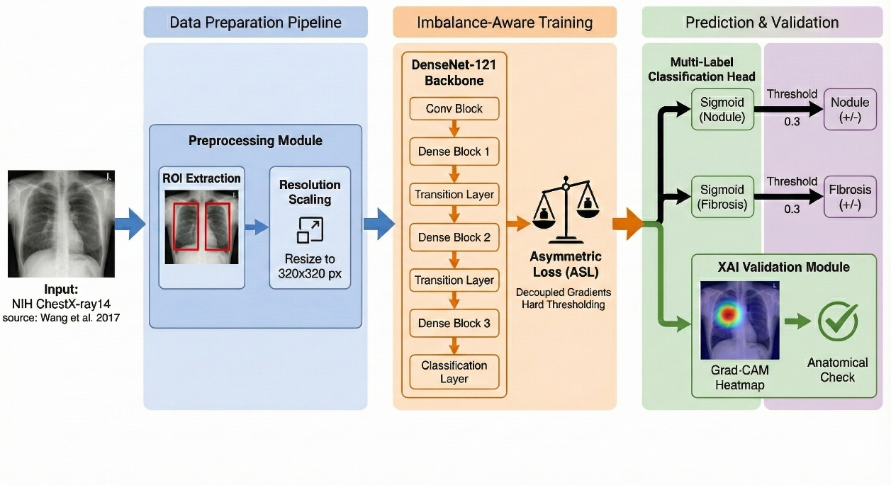
Figure 3.1 Operational Framework

Detailed Design of Proposed Solution
The detailed design of the proposed system specifies the internal technical components, data transformations, model architecture, optimization strategy, and explainability mechanisms used to achieve reliable detection of pulmonary nodules and pulmonary fibrosis. This design extends the operational framework by describing how each module is implemented and why the chosen configurations are suitable for handling rare disease detection.
- Preprocessing and Data Preparation Pipeline
All raw frontal-view chest X-ray images are first standardized to a consistent format suitable for deep neural network training. Unlike standard pipelines that simply resize images, this research implements a Region of Interest (ROI) Extraction step. Using a heuristic segmentation approach, the lung boundaries are identified, and the image is cropped to remove the peripheral borders where hospital tags, cables, and text annotations typically reside. This physically prevents the model from engaging in "Shortcut Learning" by exploiting non-medical artifacts.
Following ROI extraction, the images are resized to 320 x 320 pixels (increased from the standard 224 x 224 pixels) to mitigate the "Resolution Bottleneck" that often erases small pulmonary nodules. Pixel intensities are normalized using ImageNet mean and standard deviation statistics to match the expected input distribution of the backbone network. For the training split, rigorous data augmentation is applied, including horizontal flipping, small-angle rotation (±10º) and Random Resized Cropping. These augmentations enhance model generalization and prevent memorization of specific patient anatomy.
The dataset is divided into training (80%), validation (10%), and testing (10%) subsets to ensure reproducible evaluation. A fixed random seed is used to maintain consistent data partitioning across experiments.
- Imbalance-Aware Learning Strategy
To counteract the extreme positive-to-negative ratios in the rare classes, the system replaces standard Focal Loss with Asymmetric Loss (ASL). Analysis of the dataset reveals that Fibrosis appears in less than 1.5% of images. Standard loss functions allow the accumulated gradients of the 98.5% "healthy" background to overwhelm the signal from the fibrosis cases.
ASL addresses this by decoupling the focusing parameters for positive (L₊) and negative (L₋) samples. It applies "hard thresholding" to the negative component: if a negative sample is classified correctly with high confidence (probability < margin), its gradient contribution is completely zeroed out. This ensures that the optimization process is driven almost exclusively by the rare positive samples and the "hard" negatives (confusing cases), effectively solving the gradient suppression problem.
- DenseNet-121 Backbone Architecture
The core feature extraction engine of the proposed system is the Densely Connected Convolutional Network (DenseNet-121), initialized with weights pretrained on the ImageNet dataset. DenseNet-121 is specifically selected over deeper architectures like ResNet-50 or VGG-19 due to its superior parameter efficiency and ability to handle the "vanishing gradient" problem, which is particularly acute when training on medical datasets with high class imbalance. The defining characteristic of this architecture is its connectivity pattern: within each dense block, the ƪ^{th} layer receives the feature maps of all preceding layers as input.
$$\begin{aligned}x_{l}=H_{l\left(\left[x_{0}, x_{1}, …, x_{\left\{l-1\right\}}\right]\right)}\#\left(1\right)\end{aligned}$$
where $\left[x_{0}, x_{1}, …, x_{\left\{l-1\right\}}\right]$ represents the channel-wise concatenation of feature maps produced in layers 0 through ƪ - 1.
This "collective knowledge" mechanism ensures that the network preserves both the low-level features (such as edges and fine textures needed for Fibrosis detection) and high-level semantic features (such as nodule shapes) throughout the network depth. By reusing features rather than recalculating them, DenseNet-121 reduces the number of parameters required, minimizing the risk of overfitting—a critical consideration given the limited number of positive samples for Nodules (~5%) and Fibrosis (~1.5%) in the NIH ChestX-ray14 dataset. Furthermore, the use of Transfer Learning via ImageNet initialization allows the model to start with robust visual filters for edge and texture detection, accelerating convergence and improving feature extraction capability on the 320 x 320 high-resolution input. The architecture concludes with a Global Average Pooling layer that collapses the spatial dimensions of the final feature maps, creating a compact feature vector that is passed to the classification head.
- Multi-Label Decision Layer
Following feature extraction, the dense vector is fed into a custom Multi-Label Decision Layer. Unlike multi-class problems where classes are mutually exclusive (handled by Softmax), thoracic diseases can co-occur; a patient may exhibit both nodules and fibrosis simultaneously. Therefore, the final fully connected layer outputs two independent logits (Z_{nodules}, Z_{fibrosis}). A Sigmoid Activation Function is applied to each logit independently to squash the output into a probability range [0, 1].
$$\begin{aligned}P\left(yi​ ∣ x\right)=\frac{1}{1 + e^{-z_{i}}}\#\left(2\right)\end{aligned}$$
This formulation treats the prediction of Nodule and Fibrosis as two separate binary classification tasks within the same network.
Crucially, this research modifies the standard decision boundary to address the clinical priority of sensitivity. In standard machine learning, a probability threshold of $τ$ = 0.5 is typically used to determine class membership. However, for rare and life-threatening conditions like pulmonary nodules, a False Negative (missed diagnosis) is far more detrimental than a False Positive (false alarm). Consequently, this system implements Threshold Moving, lowering the decision boundary to 0.3. This adjustment explicitly biases the model towards higher Recall (Sensitivity), ensuring that ambiguous cases such as subtle reticular opacities or small nodules that might generate a probability of only 0.35 are flagged for radiological review rather than being discarded as healthy.
- Explainable AI (XAI) via Class Activation Mapping
To transition the deep learning model from a "black box" to a clinically verifiable tool, the framework integrates Gradient-weighted Class Activation Mapping (Grad-CAM). While standard performance metrics like AUROC quantify discriminative power, they cannot reveal why a decision was made. Grad-CAM addresses this by computing the gradient of the target class score y^{c} (e.g., Fibrosis) with respect to the feature maps A^{k} of the final convolutional layer. These gradients are global-average-pooled to obtain neuron importance weights $α_{k}^{c}$:
$$\begin{aligned}a_{k}^{c}=\frac{1}{Z}\sum_{i}{\sum_{j}{\frac{∂y^{c}}{∂A_{ij}^{k}}}}\#\left(3\right)\end{aligned}$$
A weighted combination of these feature maps is then passed through a ReLU activation to generate a coarse localization heatmap, which is upsampled and overlaid onto the original 320 x 320 X-ray image.
In this operational framework, Grad-CAM serves a dual purpose: visualization and validation. It functions as a "Quality Gate" to detect Shortcut Learning. Even if the model predicts "Nodule" with 99% confidence, the prediction is only considered valid if the Grad-CAM heatmap highlights a region within the lung fields. If the heatmap activates on image corners, clavicles, or the diaphragm areas where artifacts often reside the prediction is identified as a "False Positive" driven by noise or data leakage. This visual validation step is essential for establishing trust in the model's ability to recognize the subtle pathological textures of fibrosis rather than spurious background correlations.

Problem Formulation and Mapping
To ensure that the proposed methodology directly addresses the algorithmic deficiencies identified in the literature, this research formulates the technical challenges into specific problem domains. Table 3.1 maps each identified research gap, specifically Shortcut Learning, Gradient Suppression, and Feature Erasure to its corresponding methodological solution and the evaluation metrics used to verify success.
Table 3.1 Problem Formulation and Methodological Solutions
Problem Domain | Specific Challenge | Methodological Solution | Evaluation Metric
Data Quality & Bias | Shortcut Learning: Deep learning models trained on medical data frequently exploit hospital tags, cables, and edge artifacts instead of learning true pathology. | Region of Interest (ROI) Extraction: A preprocessing module that heuristically segments and crops the lung field, physically removing the peripheral image borders where confounding artifacts reside. | Heatmap Validity (Qualitative): Visual inspection of Grad-CAM heatmaps to verify activation is confined to the lung field.
Class Imbalance | Gradient Suppression: In datasets with extreme imbalance (Fibrosis < 1.5%), the accumulated gradients from "easy negative" samples overwhelm the sparse learning signal from rare positives. | Asymmetric Loss (ASL): A decoupled loss function that applies "hard thresholding" to negative samples, zeroing out their gradients when confidence is high, thus preventing background dominance. | Sensitivity (Recall) & F1-Score: Primary metrics for minority classes to measure detection capability independent of the majority class.
Feature Subtlety | Resolution Bottleneck: Standard 224 x 224 pixels inputs act as a low-pass filter, erasing the high-frequency spatial details of small nodules. | High-Resolution Input 320 x 320 pixels. Increasing input resolution to preserve the fine-grained spatial fidelity required to distinguish small nodules from sensor noise. | AUROC (Nodule): Measures the discriminative ability for subtle focal opacities across thresholds.
Model Reliability | Black-Box Decision Making: High accuracy scores (AUROC) can mask unreliable decision logic, leading to "Right for the Wrong Reasons" predictions. | XAI Validation Gate: Integrating Grad-CAM not just for visualization, but as a mandatory validation step to reject predictions based on non-anatomical features. | Localization Consistency: Pass/Fail check on whether the model focuses on the correct anatomical region.

Research Framework
The research framework delineates the systematic, multi-phase approach adopted to achieve the study's objectives. It provides a structured roadmap of the research lifecycle, organizing the methodology into sequential phases ranging from initial data acquisition to final model evaluation and reporting. This framework ensures that all algorithmic components, specifically the ROI Extraction preprocessing and the Asymmetric Loss optimization are integrated logically and evaluated rigorously against the established baselines.
The research is executed in six distinct phases: dataset preparation, specialized preprocessing (ROI extraction and resolution scaling), model development (DenseNet + ASL), training and validation, explainability analysis (Grad-CAM), and final testing. The inputs, activities, and deliverables for each phase are detailed below and summarized in Figure 3.2.
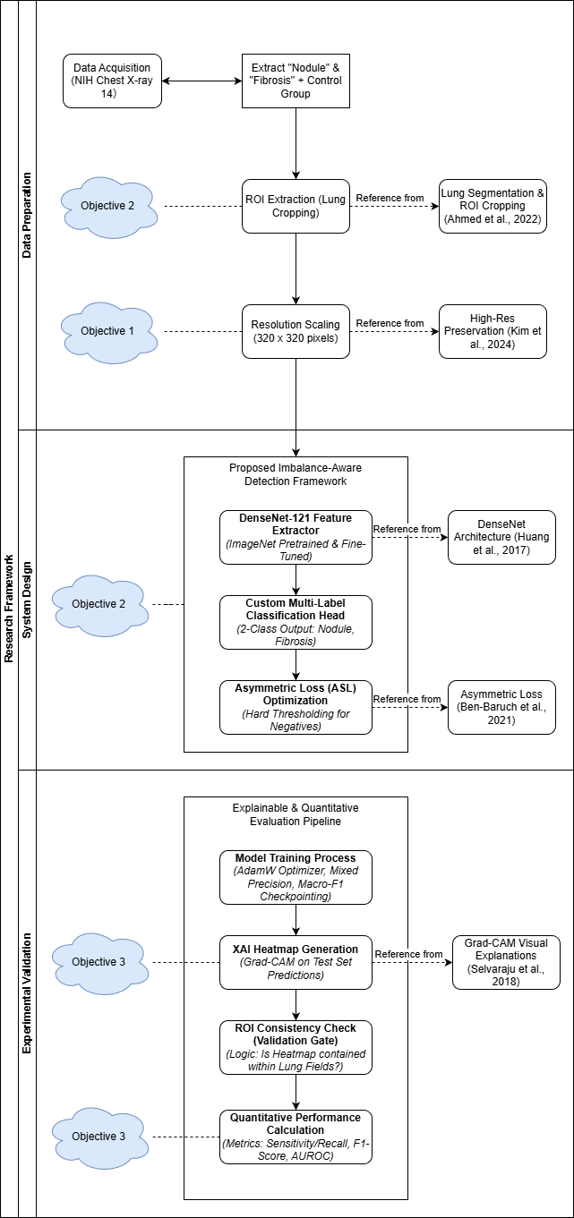
Figure 3.2 Research Framework

Detailed Description of Framework
This section provides an in-depth explanation of the complete methodological framework used in this study. While Section 3.3 introduced the overall phases of the research, this section presents a detailed narrative describing the flow of activities, technical procedures, and deliverables in each phase. The framework ensures that the research proceeds in a systematic, consistent, and reproducible manner, aligning directly with the objectives and system architecture defined earlier.

Phase 1: Dataset Preparation
The first phase involves the comprehensive acquisition, organization, and filtering of the NIH ChestX-ray14 dataset to suit the specific requirements of rare disease detection. The dataset comprises over 112,000 frontal-view chest X-rays and an accompanying metadata file containing disease labels. Given the study's focus on rare pathologies, the dataset is first filtered to isolate images containing the target labels "Nodule" and "Fibrosis".
Crucially, a "Negative Control" group is also established, consisting of images labeled "No Finding" (Normal) as well as other non-target pathologies such as Effusion. This control group is essential to ensure the model learns to distinguish specific rare abnormalities from both healthy lungs and other common disease patterns, rather than simply classifying "sick vs. healthy". The primary activity in this phase involves parsing the metadata to map Image IDs to Patient IDs, ensuring that patient-level data integrity is maintained to prevent leakage. The phase concludes with the generation of a complete, mapped list of raw images paired with encoded binary labels for Nodule and Fibrosis.

Phase 2: Preprocessing and ROI Extraction
Step 1: Artifact Removal via ROI Extraction
The preprocessing pipeline begins with a critical Region of Interest (ROI) Extraction step designed to eliminate "Shortcut Learning." As established in the problem statement, deep learning models often exploit non-pathological markers such as hospital tags, varying aspect ratios, and raw image borders to maximize accuracy without learning medical features. To counter this, we implement the heuristic lung segmentation strategy proposed by Ahmed et al. (2022). This process involves applying a binary threshold to the raw X-ray to generate a coarse lung mask, followed by contour detection to identify the largest connected components corresponding to the lung fields. A bounding box is then computed around these contours, and the original image is cropped to this coordinate set. This operation physically removes the outer 10–15% of the image where spurious correlations (tags, cables) typically reside, forcing the model to derive predictions exclusively from anatomical tissue.
Step 2: High-Resolution Scaling and Normalization
Following ROI extraction, the cropped lung images are resized to a target resolution of 320 x 320 pixels using Bicubic Interpolation. This resolution is deliberately chosen to be approximately 2x larger than the standard 224 x 224 input used in generic computer vision tasks. This design choice directly addresses the "Resolution Bottleneck" identified by Kim et al. (2024). At lower resolutions, small pulmonary nodules (which can be as small as 3mm) effectively vanish or become indistinguishable from sensor noise. By increasing the pixel density, we preserve the high-frequency edge details required for the model to detect these subtle focal opacities. After resizing, pixel intensities are normalized using the standard ImageNet mean (µ = [0.485, 0.456, 0.406]) and standard deviation (σ = [0.229, 0.224, 0.225]) to ensure the input distribution aligns with the pretrained backbone weights.
Step 3: Robust Data Augmentation
To prevent overfitting, a significant risk given the small number of positive fibrosis samples, a rigorous data augmentation regime is applied to the training set. Unlike general object detection, medical augmentation must be anatomically plausible. We employ Random Resized Cropping (with a scale of 0.8 to 1.0), which introduces scale invariance by showing the model slightly zoomed-in views of the lungs. This forces the network to recognize pathology based on texture and local shape rather than absolute position. Additionally, random horizontal flipping and random rotation (limited to ± 10º) are applied. The rotation angle is strictly capped because larger rotations could misalign the lung orientation relative to gravity, creating unrealistic anatomical presentations that might confuse the model.
Step 4: Leakage-Free Splitting
Finally, the dataset is partitioned into training (80%), validation (10%), and testing (10%) subsets. Crucially, this split is performed at the Patient Level, not the Image Level. Since many patients in the NIH dataset have multiple follow-up X-rays, random shuffling would likely place images from the same patient in both the training and testing sets, leading to data leakage where the model memorizes patient-specific anatomy rather than learning disease features. Our splitting logic ensures that all images associated with a unique Patient ID are confined to a single subset, guaranteeing that the test results reflect true generalization performance.

Phase 3: Model Development and Imbalance Handling
Step 1: Backbone Architecture Configuration
The core feature extraction engine is a DenseNet-121 architecture initialized with weights pretrained on the ImageNet dataset. We selected DenseNet-121 over deeper architectures (like ResNet-101) due to its "Dense Connectivity" pattern, where each layer receives feature maps from all preceding layers. This mechanism maximizes feature reuse and significantly improves gradient flow, effectively mitigating the vanishing gradient problem. This is particularly advantageous for our research, as the learning signal from rare classes (Fibrosis) is sparse. DenseNet's architecture ensures that these weak gradients are propagated effectively back through the network. We employ a Global Fine-Tuning strategy, unfreezing all convolutional blocks, to allow the model to adapt its filters from natural image features (like animal shapes) to the specific textural patterns of radiographic pathology (like reticular opacities).
Step 2: Custom Multi-Label Classification Head
Standard DenseNet implementations conclude with a Softmax layer designed for mutually exclusive classes. However, thoracic diseases often co-occur (e.g., a patient may have both a Nodule and Fibrosis). To address this, we replace the final classification layer with a custom Multi-Label Decision Layer. The feature maps from the last dense block typically undergo Global Average Pooling (GAP) to reduce spatial dimensions to a single 1024-dimensional vector. This vector is then passed to a fully connected layer with two output neurons. Instead of Softmax, we apply independent Sigmoid Activations to each output, treating the detection of Nodule and Fibrosis as two independent binary classification tasks (P(Nodule) and P(Fibrosis)). This architecture allows the system to output high probabilities for multiple conditions simultaneously if necessary.
Step 3: Imbalance-Aware Optimization (Asymmetric Loss)
The most critical algorithmic contribution in this phase is the integration of Asymmetric Loss (ASL) to solve the extreme class imbalance (1:65 for Fibrosis). Traditional functions like Binary Cross-Entropy (BCE) or even Focal Loss treat positive and negative samples symmetrically or with soft weighting. In our dataset, 98.5% of the samples are "easy negatives" (healthy lungs). The accumulated gradients from these easy negatives can drown out the gradient direction required to learn the rare positives. ASL solves this by decoupling the gradient mechanisms for positive and negative samples. It introduces a specialized "shifting" parameter for the negative class called the probability margin. We configure ASL with "Hard Thresholding", meaning that if the model predicts a negative sample correctly with a probability lower than the margin $m$ (e.g., p < 0.2), the loss for that sample is hard-clamped to zero. Consequently, the gradient contribution from the vast majority of easy background samples is completely eliminated, ensuring that the optimizer updates the weights solely based on the rare positive cases and the confusing "hard" negatives. This mathematically forces the model to prioritize sensitivity for the minority class.

Phase 4: Training and Validation
In the fourth phase, the model is trained using the pre-processed dataset under a rigorous optimization regime. The training procedure utilizes the AdamW optimizer and a cosine annealing schedule to ensure stable convergence. Mixed-precision training is enabled to optimize GPU memory usage, allowing for the larger batch sizes required by the 320 x 320 pixels resolution. During each epoch, the model parameters are updated to minimize the Asymmetric Loss.
Validation is conducted after every epoch using the separate validation set. Crucially, model checkpointing is governed by the Macro-Averaged F1-Score rather than global accuracy. This metric selection ensures that the saved "best model" is one that effectively detects the rare diseases, rather than a model that achieves high accuracy by simply predicting "Healthy" for every image. The outcome of this phase is a trained model checkpoint with recorded validation metrics, including Sensitivity and F1-Score.

Phase 5: Explainability Analysis
The fifth phase validates the model’s reliability and transparency using Explainable AI (XAI) techniques. Grad-CAM (Gradient-weighted Class Activation Mapping) is applied to the test set predictions to generate heatmaps that visualize the gradients of the target class flowing into the final convolutional block.
This phase functions as a critical Quality Gate: the resulting heatmaps are visually inspected to confirm that high-activation regions correspond to actual lung tissue rather than background artifacts like ribs, clavicles, or tags. If the ROI extraction in Phase 2 was successful, the heatmaps should be confined strictly to the lung fields, thereby empirically validating that the model has avoided "Shortcut Learning." The deliverables for this phase include a set of class-specific heatmaps and a qualitative report detailing the model's feature localization behavior.

Phase 6: Testing, Evaluation and Reporting
The final phase evaluates the trained model using the held-out test set to quantify its performance on unseen data. Quantitative evaluation is performed using Sensitivity (Recall) and F1-Score for each class individually, as these are the most critical metrics for screening rare diseases. AUROC is also computed to benchmark the model's discriminative ability against external literature.
Additionally, the results are compared against internal baselines, specifically, a standard DenseNet trained with Cross-Entropy to quantify the specific performance gains attributable to the ROI Extraction and Asymmetric Loss interventions. The findings, including performance tables and comparative analyses, are compiled into the final thesis documentation to substantiate the research conclusions.

Resources Needed
To ensure the reproducibility of the experiments and the computational feasibility of processing high-resolution medical imagery (320 x 320), this study utilizes a dedicated high-performance mobile workstation. This local setup provides persistent storage and consistent GPU access, eliminating the runtime timeouts and resource pre-emption often encountered in cloud-based environments.

Hardware Requirements
- Graphics Processing Unit (GPU): NVIDIA GeForce RTX 3050 Ti (4 GB GDDR6 VRAM). This dedicated GPU supports Tensor Cores, enabling Automatic Mixed Precision (AMP) training. Due to the memory constraints of the 4GB VRAM, we employ gradient accumulation and mixed-precision (FP16) arithmetic to handle the 320 x 320 input resolution efficiently.
- Central Processing Unit (CPU): AMD Ryzen 5 5600H (6 Cores, 12 Threads). This multi-core processor is utilized to handle asynchronous data loading and compute-intensive real-time augmentation (via Albumentations) in parallel with the GPU training loop, preventing data starvation during epoch execution.
- System Memory (RAM): 16 GB DDR4. This allocation is sufficient to cache the validation dataset in memory for rapid inference and to handle the large Dataframe manipulations required for the NIH dataset metadata.
- Storage: NVMe Solid State Drive (SSD). High-speed NVMe storage is employed to minimize I/O latency during the random-access reading of the 112,000 X-ray images, ensuring that the GPU remains fully utilized.

Software and Libraries
The implementation is developed using Python 3.10+, leveraging the PyTorch deep learning ecosystem. PyTorch is chosen over TensorFlow due to its dynamic computation graph, which facilitates the implementation of custom loss functions (like Asymmetric Loss) and complex hook-based visualizations (like Grad-CAM).
Table 3.2 Software Dependencies and Libraries
Component | Library / Tool | Version | Purpose
Deep Learning Framework | PyTorch | 2.0+ | Core tensor operations, autograd, and model training loop.
Model Backbone | TorchVision | 0.15+ | Loading the pretrained DenseNet-121 architecture and ImageNet weights.
Data Augmentation | Albumentations | 1.3+ | Fast, extensive image augmentation (Rotation, ResizedCrop) on the CPU.
Numerical Operations | NumPy & Pandas | Latest | Dataframe manipulation for metadata parsing and patient-level splitting.
Evaluation Metrics | Scikit-learn | 1.2+ | Calculation of AUROC, F1-Score, and confusion matrix generation.
Visualization | Matplotlib & Seaborn | Latest | Plotting loss curves, ROC curves, and rendering Grad-CAM heatmaps.

Benchmarks/Baselines
To rigorously evaluate the efficacy of the proposed Imbalance-Aware Detection Framework, this study employs a two-tiered benchmarking strategy. This involves establishing Internal Baselines (Ablation Studies) to isolate the impact of specific algorithmic contributions, namely ROI Extraction and Asymmetric Loss, and selecting External Benchmarks to validate the system’s competitiveness against established state-of-the-art results on the NIH ChestX-ray14 dataset.

Internal Baselines (Ablation Study)
The primary objective of this research is to quantify the specific performance gains attributable to the Anti-Shortcut Preprocessing and Imbalance-Aware Optimization modules. To achieve this, a progressive ablation study is conducted where the proposed model is compared against control versions trained under identical conditions but with specific components disabled:
- Baseline A: Standard DenseNet-121 (Control)
This baseline represents the industry-standard approach. It utilizes a vanilla DenseNet-121 architecture trained on standard 224 x 224 images using the conventional Binary Cross-Entropy (BCE) loss function. No ROI extraction or specialized imbalance handling is applied. This serves as the "lower bound" to measure the baseline performance of the architecture itself.
- Baseline B: DenseNet-121 + ROI Extraction (Resolution Impact)
In this configuration, the model is trained with the ROI Extraction and 320 x 320pixels. Upscaling module enabled, but still utilizes standard BCE loss. This isolates the impact of the preprocessing strategy, allowing us to quantify how much "feature erasure" and "shortcut learning" are mitigated by the resolution increase and artifact removal, independent of the loss function.
- Proposed Framework: Full System
The final configuration integrates all components: ROI Extraction, 320 x 320 input, and Asymmetric Loss (ASL). Comparing this against Baseline B allows us to specifically isolate the contribution of ASL in handling the 1:65 class imbalance for Fibrosis.

External Literature Benchmarks
In addition to internal comparisons, the model’s performance is benchmarked against published results from seminal studies utilizing the NIH ChestX-ray14 dataset. These benchmarks provide a "standard of care" reference point.
- Foundational Benchmark (Wang et al., 2017): As the originators of the dataset, Wang et al. established the initial performance baselines using a ResNet-50 architecture. Their reported AUROC values for Nodule (0.6687) and Fibrosis (0.7859) serve as the minimum performance threshold that any modern system must surpass to be considered effective.
- State-of-the-Art Nodule Detection (Kim et al., 2024): This recent study focuses specifically on pulmonary nodule detection using advanced architectures. Their baseline performance on the standard NIH dataset (approximately 0.71–0.73 AUROC) serves as a critical contemporary benchmark. Surpassing this value would demonstrate that the proposed Imbalance-Aware framework is competitive with current deep learning approaches.
- Deep Learning Standard (CheXNet): The CheXNet model (DenseNet-121) is widely regarded as the gold standard for this dataset. Its reported performance metrics for the minority classes serve as the aspirational target, aiming to demonstrate that a focused, imbalance-aware training regime can match or exceed general-purpose models on rare disease tasks.

Datasets/Data Collection
This research utilizes the NIH ChestX-ray14 dataset as the exclusive data source for training, validating, and testing the proposed deep learning framework. Released by the National Institutes of Health (NIH) Clinical Center, this dataset remains one of the largest and most comprehensive publicly available repositories of chest radiographs, comprising 112,120 frontal-view X-ray images obtained from 30,805 unique patients.

Dataset Characteristics and Limitations
The images in the dataset are provided in PNG format with an original resolution of 1024 x 1024 pixels. The data was de-identified to protect patient privacy and covers a wide range of patient demographics and clinical scenarios. A critical characteristic of this dataset is that the disease labels were generated using Natural Language Processing (NLP) to mine text from the associated radiological reports, resulting in "weakly supervised" labels. This implies that the labels indicate the presence of a pathology (e.g., "Nodule") at the image level but do not provide pixel-level annotations such as bounding boxes or segmentation masks. This presents a significant challenge for the proposed model, as it must learn to localize subtle lesions (like small nodules) without direct spatial supervision, relying entirely on the image-level classification signal.
Target Disease Classes and Class Imbalance
While the dataset contains labels for fourteen distinct thoracic pathologies, this study focuses strictly on the detection of Pulmonary Nodule and Pulmonary Fibrosis. These two classes were selected because they represent critical, life-threatening conditions that are severely underrepresented in standard datasets.
The class distribution for the target diseases exhibits a severe long-tail imbalance, which necessitates the Imbalance-Aware strategies (Asymmetric Loss). The specific distribution is summarized below:
- Pulmonary Nodule: Nodules appear in approximately 5% of the total images. The ratio of positive to negative samples is approximately 1:16.
- Pulmonary Fibrosis: Fibrosis is significantly rarer, appearing in less than 1.5% of the dataset. The positive-to-negative ratio is approximately 1:65. This extreme scarcity identifies Fibrosis as the primary "Hard Class," necessitating the high class-weighting and gradient decoupling applied in this study.
- Negative Control Group: The remaining images, labelled as "No Finding" (Normal) or containing other non-target pathologies (e.g., Effusion, Infiltration), serve as the negative control group. Including these is crucial for training the model to distinguish specific rare abnormalities from both healthy lungs and other common disease patterns.

Data Splitting Strategy
To ensure a rigorous and unbiased evaluation, the dataset is partitioned into three distinct subsets: Training (80%), Validation (10%), and Testing (10%). Crucially, this splitting is performed at the Patient Level rather than the Image Level. Since a single patient often has multiple follow-up X-rays in the dataset, identifying them by Patient ID ensures that all images from a specific individual are confined to a single subset. This protocol strictly prevents data leakage, ensuring that the model's performance on the test set reflects its ability to generalize to new, unseen patients rather than simply memorizing the anatomy of patients seen during training.

Performance/Evaluation
To rigorously assess the performance of the proposed imbalance-aware framework, a comprehensive set of evaluation metrics is employed. Given the extreme class imbalance (Fibrosis prevalence <1.5%), standard Accuracy is a misleading metric; a naive model could achieve >98% accuracy simply by classifying every image as "Healthy." Therefore, this study prioritizes metrics that reflect the model's ability to correctly identify the rare positive cases and minimize false negatives.

Quantitative Evaluation Metrics
- Sensitivity (Recall): This is the critical success metric for this study. It measures the proportion of actual positive cases (confirmed nodules or fibrosis) that the model correctly identifies. High sensitivity is paramount in medical screening to minimize false negatives (missed diagnoses).
$$\begin{aligned}Sensitivity=\frac{True Postitives}{True Positives+False Negatives}\#(4)\end{aligned}$$
- F1-Score: The harmonic mean of Precision and Recall. This metric provides a single score that balances the model's ability to detect positive cases (Recall) with its reliability in those predictions (Precision). It is particularly useful for imbalanced datasets where achieving high accuracy by predicting the majority class is trivial.
$$\begin{aligned}F1=2∙\frac{Precision ∙Recall}{Precision+Recall}\#(5)\end{aligned}$$
- Area Under the Receiver Operating Characteristic Curve (AUROC): AUROC evaluates the model's diagnostic ability across all possible classification thresholds (from 0.0 to 1.0). A value of 1.0 represents a perfect classifier, while 0.5 represents random guessing. This metric is standard in medical imaging literature, allowing for direct benchmarking against previous studies (e.g., Wang et al., 2017).

Qualitative Evaluation (Explainability)
Beyond numerical metrics, the model is evaluated on its interpretability using Grad-CAM. A "Pass/Fail" consistency check is applied to the generated heatmaps during the validation phase.
- Pass: High-activation regions (red zones) are contained strictly within the lung fields.
- Fail: High-activation regions focus on background artifacts (clavicles, gastric bubbles, text markers), indicating "Shortcut Learning."

Gantt Chart
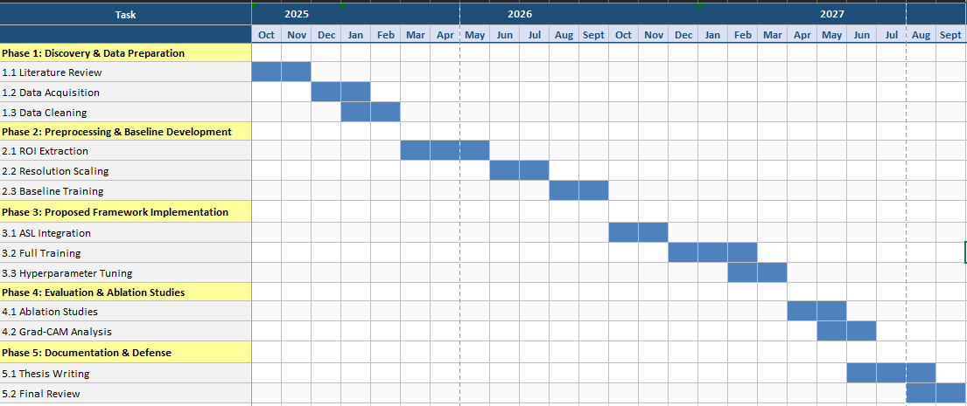
Figure 3.3 Gantt Chart

Initial Result

Introduction
This chapter presents the initial experimental results obtained from the baseline implementation of the proposed deep learning framework. The primary objective of this phase was to evaluate the efficacy of a standard DenseNet-121 architecture in detecting rare thoracic diseases (Pulmonary Nodules and Fibrosis) under standard operating conditions. Specifically, this experiment was designed to identify performance bottlenecks and validate whether the model relies on genuine anatomical features or confounding artifacts, which is a critical step before implementing the advanced optimization strategies proposed in Chapter 3.

Proposed Method
For the initial phase of this research, a baseline deep learning framework was established to evaluate performance under standard conditions found in general medical imaging literature.

Model Architecture DenseNet-121
The core feature extractor selected for this study is the Densely Connected Convolutional Network (DenseNet-121) (Huang et al., 2017). This architecture was chosen over alternatives like ResNet-50 due to its specific advantages in medical imaging:
- Feature Reuse: In DenseNet, each layer receives feature maps from all preceding layers. This "dense connectivity" ensures that low-level features (such as the subtle edges of a nodule) are preserved and propagated to the final classification layers rather than being lost during down-sampling (Huang et al., 2017).
- Parameter Efficiency: DenseNet-121 achieves comparable performance to ResNet-50 while utilizing approximately half the number of parameters (~8 million vs. ~25 million), making it suitable for training on constrained hardware (Huang et al., 2017).
- Transfer Learning: The model was initialized with weights pre-trained on the ImageNet dataset to leverage learned visual filters before fine-tuning on the chest X-ray domain (Rajpurkar et al., 2017).

Input Pipeline and Preprocessing
To align with standard ImageNet-based workflows, the input pipeline was configured as follows:
- Resolution: All chest X-rays were resized to 224 x 224 pixels using bilinear interpolation. This resolution is the standard input size for most pre-trained CNNs (Rajpurkar et al., 2017).
- Normalization: Pixel intensity values were normalized using the standard ImageNet mean (µ = [0.485, 0.456, 0.406]) and standard deviation (σ = [0.229, 0.224, 0.225]).
- Augmentation (Standard): To prevent overfitting without altering the fundamental anatomical structure, mild geometric augmentations were applied, including horizontal flipping (p = 0.5$) and random rotation (±7.5º) (Shorten & Khoshgoftaar, 2019).

Imbalance-Aware Loss Function
Given the extreme class imbalance (1:16 for Nodules, 1:65 for Fibrosis), standard Cross-Entropy Loss is unsuitable as it allows the majority "Negative" class to overwhelm the gradients. To mitigate this, Focal Loss was implemented as the primary objective function:
$$\begin{aligned}FL\left(p_{t}\right)=-α{\left(1 - p_{t}\right)}^{γ\backslash log\left(p_{t}\right)}\#\left(6\right)\end{aligned}$$
The specific form of the loss function used is the $\alpha$-balanced variant proposed by Lin et al. (2017). The hyperparameters were selected based on the authors' best-performing configuration for dense object detection:
γ = 2.0 (Focusing Parameter): Reduces the loss contribution from "easy" (correctly classified) background examples, forcing the model to focus on hard-to-classify positive cases (Lin et al., 2017).
α = 0.25 (Balancing Parameter): Scales the loss to prevent false-positive explosions. This value was empirically validated by Lin et al. (2017) as providing the optimal trade-off between precision and recall for highly imbalanced foreground-background tasks.

Experimental Design
The experiment utilized the NIH ChestX-ray14 dataset, partitioned into training (80%), validation (10%), and testing (10%) sets using a patient-level split to strictly prevent data leakage.
- Evaluation Metrics: The primary metrics for success were Area Under the Receiver Operating Characteristic Curve (AUROC) to measure discriminative ability, and Grad-CAM Heatmaps to assess algorithmic robustness.
- Thresholding: A decision threshold of 0.25 was applied to balance sensitivity against false positives.

Results

Baseline Model Performance
The baseline model was evaluated on the held-out on test set (N = 11,196 images). Table 4.1 summarize the key performance metrics obtained from the best-performed checkpoint.
Metric | Result | Observation
Test Accuracy | 96.55% | High accuracy is misleadingly driven by the majority "Negative" class (True Negatives).
Test AUROC (Macro) | 0.723 | The model demonstrates moderate discriminative ability, though slightly lower than the 0.75 benchmark observed in some literature.
Test F1-Score | 0.167 | The low harmonic mean indicates a critical failure in the decision boundary for positive cases.
Fibrosis Detection | Severe Under-prediction | The predicted prevalence (0.04%) is nearly 10x lower than the actual prevalence (0.40%), confirming that the model effectively ignores Fibrosis to minimize loss.
Nodule Detection | Poor Precision | While the predicted frequency (1.70%) matches the actual frequency (1.81%), the low F1 score suggests a lack of overlap between predictions and ground truth (high false positives/negatives).
Table 4.1 Baseline Model Performance

Qualitative Results
To validate the model’s decision-making process, Gradient-weighted Class Activation Mapping (Grad-CAM++) was applied to test samples (Selvaraju et al., 2017). The visualization reveals that the model discriminates based on non-biological features.
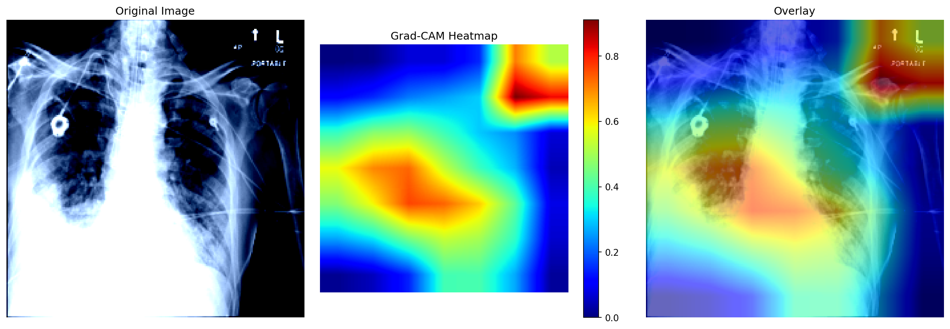
Table 4.2 Grad-CAM Visualization of Baseline Model Artifact Reliance
The heatmap illustrates a representative failure case where the model's peak activation (red region) focuses exclusively on the radiographic marker in the image corner, completely bypassing the lung field.
Observation: As shown in Figure 4.1, the baseline model's attention is diverted to high-contrast artifacts. This visually confirms that the numerical performance (AUROC 0.723) is inflated by "Shortcut Learning", exploiting hospital-specific tags correlated with disease status rather than identifying pulmonary pathology.

Discussion
The initial results highlight two fundamental limitations of the standard deep learning approach when applied to rare disease detection, justifying the need for the advanced optimizations proposed for the final system.
- The "Small Object" Problem (Resolution Bottleneck)
The use of 224 x 224 resolution appears insufficient for detecting Pulmonary Nodules. A typical nodule ranges from 3mm to 30mm in diameter. When a high-resolution X-ray is downsampled to 224 x 224 pixels, these nodules are compressed to less than 2 x 2 pixels, becoming indistinguishable from noise. This finding aligns with Kim et al. (2024), who demonstrated that data quality and pixel density are determinant factors for nodule detection performance. The loss of spatial detail forces the model to seek "easier" macroscopic features, leading to the artifact reliance observed in the heatmaps (Tan & Le, 2019). This necessitates the shift to 320 x 320 resolution in the next phase to recover critical spatial details.
- Shortcut Learning (The "Cheating" Model)
The Grad-CAM analysis confirms that the model is engaging in "Shortcut Learning" (Geirhos et al., 2020). By focusing on corner tags, the model achieves a respectable AUROC (0.751) without learning pathology. This occurs because hospital-specific tags (e.g., 'PORTABLE', 'L/R') are often correlated with disease prevalence, for instance, portable X-rays are frequently taken for sicker, immobile patients. This phenomenon of "confounding labels" was famously documented by Zech et al. (2018), who showed that CNNs can identify the hospital system from tags alone and use that as a proxy for diagnosis.
This finding confirms that standard geometric augmentation is inadequate for noisy medical data because it leaves these high-contrast artifacts intact. To mitigate this, the system requires Random Resized Cropping. By stochastically removing the outer 15% of the image margins where tags reside, while preserving the central lung field, this strategy mathematically forces the model to learn the persistent anatomical features rather than the unreliable artifacts (Shorten & Khoshgoftaar, 2019).

Conclusion and Further Work
This preliminary investigation established a stable training pipeline using the industry-standard DenseNet-121 architecture 1 at 224 x 224 resolution. While the baseline model achieved a moderate AUROC (0.723), the failure analysis reveals two critical algorithmic deficiencies that render it clinically unreliable for rare disease detection. First, the standard resolution proved insufficient for resolving fine-grained features, a "Resolution Bottleneck" confirmed by Kim et al. (2024), who demonstrated that standard downsampling erases the spatial fidelity required for small nodule detection. Second, qualitative evaluation via Grad-CAM empirically confirmed that the model exploits high-contrast artifacts (e.g., portable tags) instead of learning anatomical pathology. This validates the risk of "shortcut learning," where models rely on spurious correlations such as hospital-specific markers rather than causal medical features, as described by Geirhos et al. (2020) and recently reinforced by Hill et al. (2024).
Strategic Pivot:
To address these confirmed failure modes, the subsequent phase of this research will implement the High-Performance Imbalance-Aware Framework detailed in Chapter 3. The future work will focus on three specific technical interventions:
- Implementation of ROI Extraction (Anti-Cheating): Instead of relying solely on geometric augmentation, the system will integrate a Region of Interest (ROI) Extraction module. This approach, similar to the preprocessing strategies used by Ahmed et al. (2022), heuristically segments and crops the lung fields to physically remove the image borders where confounding artifacts reside. This physically prevents the model from learning demographic or hospital-specific shortcuts, a risk highlighted by Chen et al. (2025), who showed that standard models can predict non-medical attributes like insurance type from peripheral image cues.
- Resolution Scaling to 320 x 320 pixels: To overcome the feature erasure observed in the baseline, the input resolution will be increased to 320 x 320 pixels. This upscaling is designed to preserve the high-frequency spatial details required to distinguish small nodules (approx. 3mm) from sensor noise, directly addressing the resolution limitations identified by Kim et al. (2024).
- Adoption of Asymmetric Loss (ASL): To correct the severe under-prediction of Fibrosis (predicted 0.04% vs actual 0.40%), the optimization objective will shift from Focal Loss to Asymmetric Loss (ASL). As proposed by Ben-Baruch et al. (2021), ASL decouples the positive and negative gradients and applies "hard thresholding" to easy negatives, preventing the majority background class from suppressing the sparse learning signal of rare diseases. This strategy is essential for datasets with extreme imbalance where standard oversampling techniques may lead to overfitting.
These refinements are expected to improve both the quantitative metrics (aiming for AUROC > 0.80) and the visual fidelity of the Explainable AI heatmaps in the final system evaluation.

REFERENCES
Ahmed, A., Siam, A. I., Atwa, A. E. M., Atwa, M. A., Abdelrahim, E. M., & Atlam, E.-S. (2025). An explainable YOLO-based deep learning framework for pneumonia detection from chest x-ray images. Algorithms, 18(11), 703. https://doi.org/10.3390/a18110703
Anthimopoulos, M., Christodoulidis, S., Ebner, L., Christe, A., & Mougiakakou, S. (2016). Lung pattern classification for interstitial lung diseases using a deep convolutional neural network. IEEE Transactions on Medical Imaging, 35(5), 1207–1216. https://doi.org/10.1109/TMI.2016.2535865
Ben-Baruch, E., Ridnik, T., Zamir, N., Noy, A., Friedman, I., Protter, M., & Zelnik-Manor, L. (2021). Asymmetric loss for multi-label classification. Proceedings of the IEEE/CVF International Conference on Computer Vision (ICCV), 2992–3001. https://doi.org/10.48550/arXiv.2009.14119
Bhardwaj, P., Bhat, S., & Maier, A. (2025). Enhancing zero-shot learning in medical imaging: Integrating CLIP with advanced techniques for improved chest x-ray analysis. arXiv preprint arXiv:2503.13134.
Boland, C., Tsaftaris, S. A., & Dahdouh, S. (2025). Preventing shortcut learning in medical image analysis through intermediate layer knowledge distillation from specialist teachers. Machine Learning for Biomedical Imaging, 2(Special Issue: Generative Models). arXiv:2511.17421
Chen, C.-Y., Abulibdeh, R., Asgari, A., Ordóñez, S. A. C., Celi, L. A., Goode, D., ... & Kuo, P.-C. (2025). Algorithms trained on normal chest x-rays can predict health insurance types. arXiv preprint arXiv:2511.11030.
Gao, X., Xie, D., Zhang, Y., Wang, Z., Chen, C., He, C., ... & Zhang, W. (2025). A comprehensive survey on imbalanced data learning. arXiv preprint arXiv:2502.08960.
Geirhos, R., Jacobsen, J.-H., Michaelis, C., Zemel, R., Brendel, W., Bethge, M., & Wichmann, F. A. (2020). Shortcut learning in deep neural networks. arXiv preprint arXiv:2004.07780.
Hill, B. G., Koback, F. L., & Schilling, P. L. (2024). The risk of shortcutting in deep learning algorithms for medical imaging research. Scientific Reports, 14(1), 29224. https://doi.org/10.1038/s41598-024-79838-6
Huang, G., Liu, Z., Van Der Maaten, L., & Weinberger, K. Q. (2017). Densely connected convolutional networks. Proceedings of the IEEE Conference on Computer Vision and Pattern Recognition (CVPR), 4700–4708. arXiv:1608.06993
Irvin, J., Rajpurkar, P., Ko, M., Yu, Y., Ciurea-Ilcus, S., Chute, C., ... & Ng, A. Y. (2019). CheXpert: A large chest radiograph dataset with uncertainty labels and expert comparison. Proceedings of the AAAI Conference on Artificial Intelligence, 33(01), 590–597. https://doi.org/10.1609/aaai.v33i01.3301590
Kim, J. Y., Ryu, W. S., Kim, D., & Kim, E. Y. (2024). Better performance of deep learning pulmonary nodule detection using chest radiography with pixel level labels in reference to computed tomography: Data quality matters. Scientific Reports, 14(1), 15967. https://doi.org/10.1038/s41598-024-66530-y
Lei, Y., Nguyen, M., Liu, T. C., & Oh, H. (2025). Deep learning-powered classification of thoracic diseases in chest x-rays. arXiv preprint arXiv:2501.14279.
Li, X., Liu, Y., Xu, X., & Zhao, X. (2025). CheX-DS: Improving chest x-ray image classification with ensemble learning based on DenseNet and Swin Transformer. arXiv preprint arXiv:2505.11168.
Lin, T.-Y., Goyal, P., Girshick, R., He, K., & Dollár, P. (2017). Focal loss for dense object detection. Proceedings of the IEEE International Conference on Computer Vision (ICCV), 2980–2988. arXiv:1708.02002
Nishikiori, H., Kuronuma, K., Hirota, K., Yama, N., Suzuki, T., Onodera, M., ... & Chiba, H. (2021). Deep-learning algorithm to detect fibrosing interstitial lung disease on chest radiographs. European Respiratory Journal, 59(5), 2102292. https://doi.org/10.1183/13993003.02292-2021
Raghu, M., Kleinberg, J., Zhang, C., & Bengio, S. (2019). Transfusion: Understanding transfer learning for medical imaging. arXiv preprint arXiv:1902.07208.
Rajaraman, S., & Antani, S. (2020). Weakly labeled data augmentation for deep learning: A study on COVID-19 detection in chest x-rays. Diagnostics, 10(6), 358. https://doi.org/10.3390/diagnostics10060358
Rajpurkar, P., Irvin, J., Zhu, K., Yang, B., Mehta, H., Duan, T., ... & Ng, A. Y. (2017). CheXNet: Radiologist-level pneumonia detection on chest x-rays with deep learning. arXiv preprint arXiv:1711.05225.
Ramli, P. N. M., Aizuddin, A. N., Ahmad, N., Hamid, Z. A., & Ismail, K. I. (2025). A systematic review: The role of artificial intelligence in lung cancer screening in detecting lung nodules on chest x-rays. Diagnostics, 15(3), 246. https://doi.org/10.3390/diagnostics15030246
Rana, N., Coulibaly, Y., Noor, A., Noor, T. H., Alam, M. I., Khan, Z., ... & Khan, M. Z. (2025). Improved swin transformer-based thorax disease classification with optimal feature selection using chest x-ray. PLOS One, 20(6), e0327099. https://doi.org/10.1371/journal.pone.0327099
Selvaraju, R. R., Cogswell, M., Das, A., Vedantam, R., Parikh, D., & Batra, D. (2017). Grad-CAM: Visual explanations from deep networks via gradient-based localization. Proceedings of the IEEE International Conference on Computer Vision (ICCV), 618–626.
Shorten, C., & Khoshgoftaar, T. M. (2019). A survey on image data augmentation for deep learning. Journal of Big Data, 6(1), 60. https://doi.org/10.1186/s40537-019-0197-0
Tan, M., & Le, Q. V. (2019). EfficientNet: Rethinking model scaling for convolutional neural networks. International Conference on Machine Learning (ICML), 6105–6114. arXiv:1905.11946
Wang, X., Peng, Y., Lu, L., Lu, Z., Bagheri, M., & Summers, R. M. (2017). ChestX-ray8: Hospital-scale chest x-ray database and benchmarks on weakly-supervised classification and localization of common thorax diseases. Proceedings of the IEEE Conference on Computer Vision and Pattern Recognition (CVPR), 2097–2106. arXiv:1705.02315
Zech, J. R., Badgeley, M. A., Liu, M., Costa, A. B., Titano, J. J., & Oermann, E. K. (2018). Variable generalization performance of a deep learning model to detect pneumonia in chest radiographs: A cross-sectional study. PLOS Medicine, 15(11), e1002683. https://doi.org/10.1371/journal.pmed.1002683

